Otite for TechP3

As a System Engineer I will create a setting that allows only the hosts in a defined network to access the DNS server and not just any other host

Project DNS

Domain name server for relationship between IP address and web addresses.

**Functionalities for maintaining DNS for Internet Service Providers:**

[Internet service providers](https://phoenixnap.com/glossary/isp-definition) use a preconfigured DNS server to filter traffic. There are many reasons to change the default DNS configuration, such as:

* **Speed improvements**. A DNS maps domain names to IP addresses. Custom DNS configuration helps improve domain name resolution times, which reduces the time needed to access a website.
* **Greater security**. Specific DNS servers block malicious web pages and focus on preventing access to [unsafe websites](https://phoenixnap.com/blog/how-to-secure-a-website). Changing the DNS configuration to use such servers improves internet security and restricts exposure to online threats.
* **Customized experience**. Configure the DNS to block access to specific web pages or reroute domain names to different addresses. For example, some DNS servers help create a family-friendly environment by blocking access to unsafe or suspicious websites.
* **Privacy**. Some DNS servers log internet queries for advertising purposes. Changing the DNS configuration to a privacy-focused server enables better control over online privacy.
* **Troubleshooting**. Changing to a different DNS server is crucial in [troubleshooting DNS issues](https://phoenixnap.com/kb/dns-troubleshooting).

**How to use the Linux BIND command to install and configure DNS**

The Domain Name System helps you get where you want to be on the internet. Make sure you know what it is and how to set up, configure, and test it.

The Domain Name System (DNS) is used to resolve (translate) hostnames to internet protocol (IP) addresses and vice versa. A DNS server, also known as a **nameserver**, maps IP addresses to hostnames or domain names.

Some of the basics of DNS, are how DNS gets the IP address and hostname, another basic of DNS is the concepts of forwarding and reverse lookup zones. I will show how to install and configure DNS, define and edit zone files, and verify whether the DNS can resolve to the correct address with the help of commands.

How DNS works

When a client requests information from a nameserver, it usually connects to port 53, and then the nameserver resolves the name requested.

Image

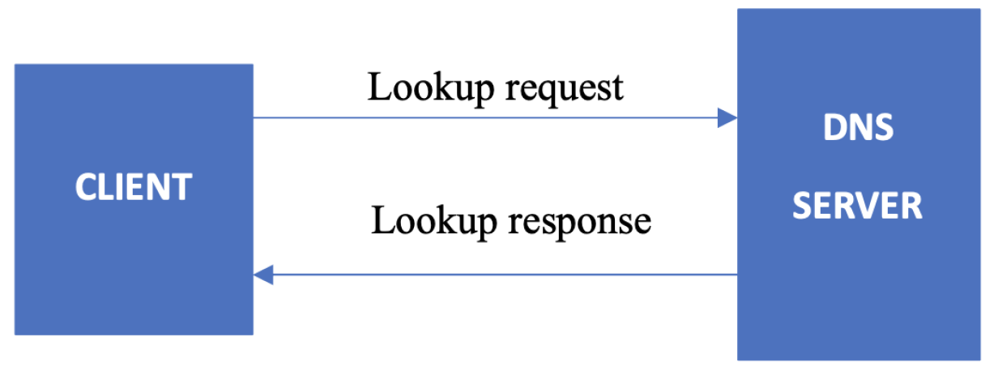

* Sending a request from the DNS client to the DNS server is called a **lookup request.**
* Getting a response from the DNS server to the DNS client is called a **lookup response**.
* The system on which the DNS service is configured is called a **DNS server**.
  + Our main box that configuration file is housed (named.conf)
* The system that accesses the DNS server is called a **DNS client**.
  + Secondary box we will use to connect as a client to the Host main box (DNS Server)

Where does DNS get IP addresses?

You might wonder how DNS gets the IP of the corresponding hostname or domain name. How does DNS search among different IP addresses and associate your domain name correctly? Who stores those mappings between domain names and IP addresses?

The DNS workflow illustrates how communication happens within DNS and how it resolves the addresses.

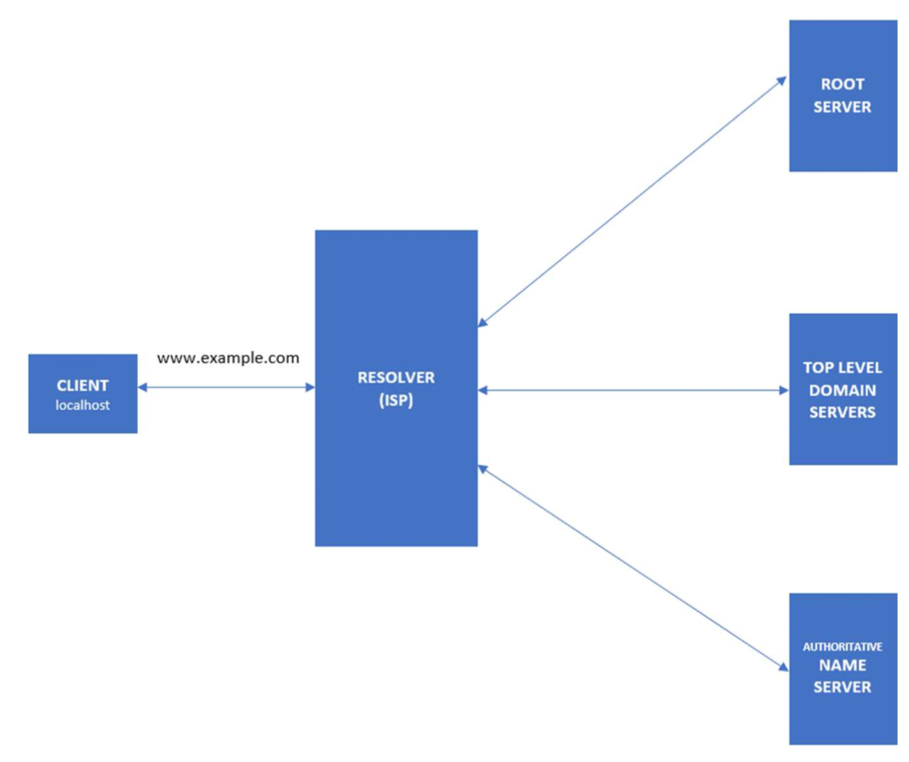

* When the client searches for the domain www.apple.com, the request will initially go to the internet service provider's (ISP) resolver. It will respond to the user's request to resolve a domain name.
* If the IP address is not found on the resolver, the request is forwarded to a root DNS server and later to the top-level domain (TLD) servers.
* TLD servers store information for top-level domains, such as **.com** or **.net**.
* Requests are forwarded to the nameservers, which know detailed information about domains and IP addresses.
* Nameservers respond to the ISP's resolver, and then the resolver responds to the client with the requested IP.
* When the resolver doesn't know the IP, it stores the IP and its domain in a cache to service future queries.

Forward and reverse lookups

The **forward lookup zone** uses the domain name to search for IP addresses, whereas the **reverse lookup zone** uses IP addresses to search for the domain name.

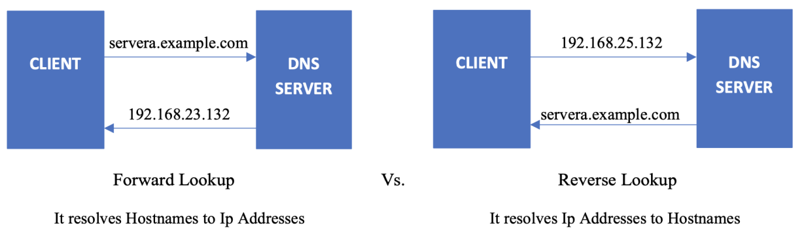

Install and configure DNS

BIND is a nameserver service responsible for performing domain-name-to-IP conversion on Linux-based DNS servers. Make sure you are logged in as root or a privileged user.

1. [root@techp3-db ~] *# yum install bind*
2. We also updated the repo packages to make sure we had all the latest updates and Epel package
3. The 1st step is installing the bind on your main box also known as the nameserver:
4. 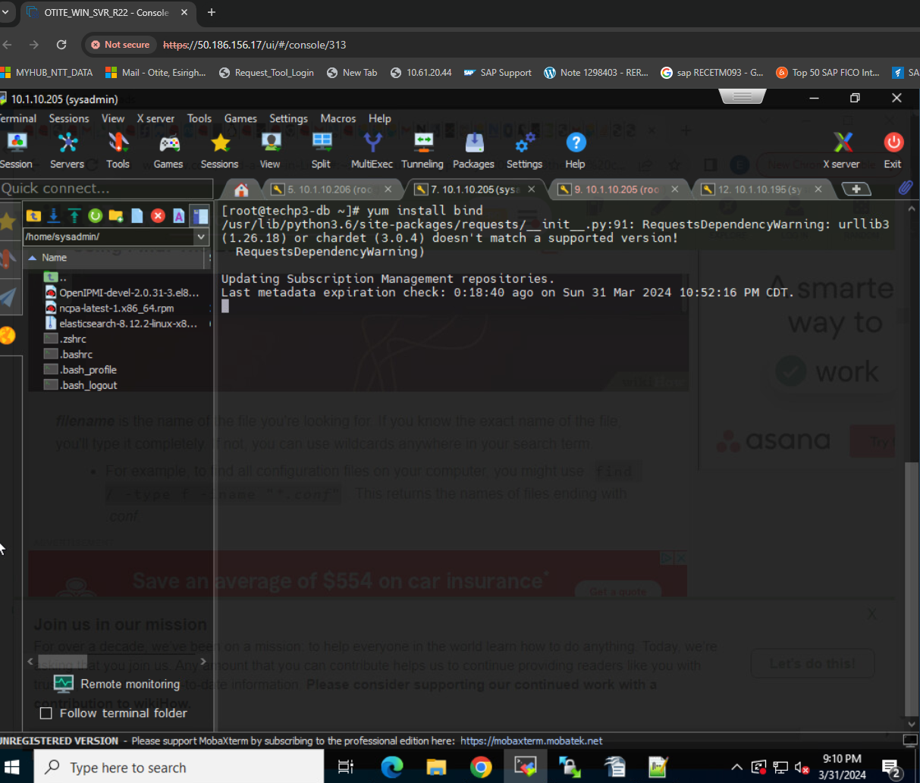
5. 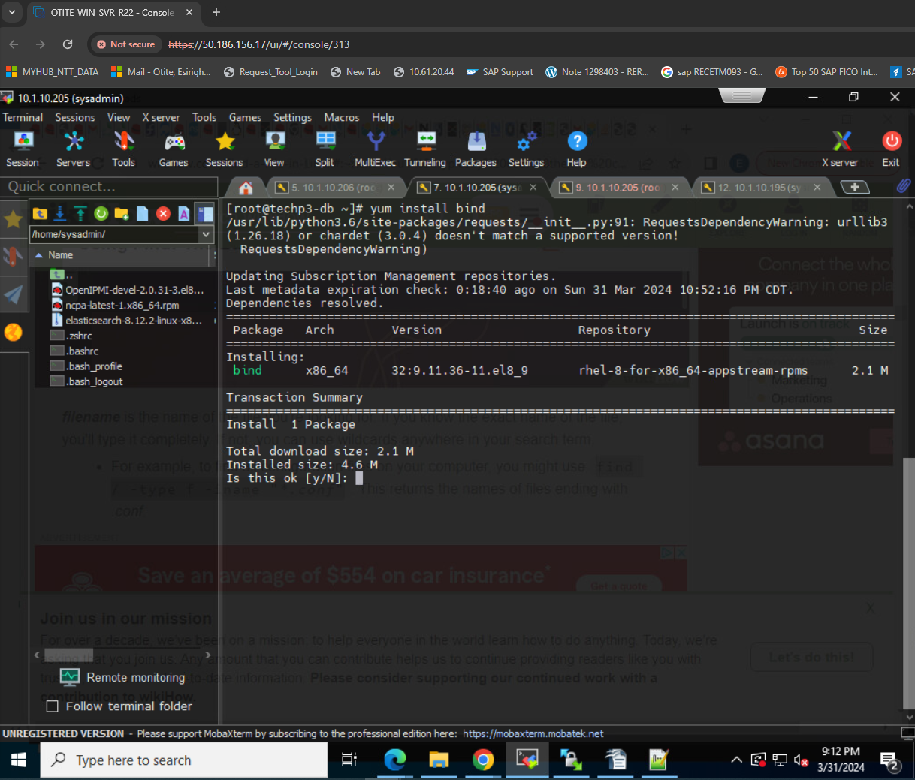
6. 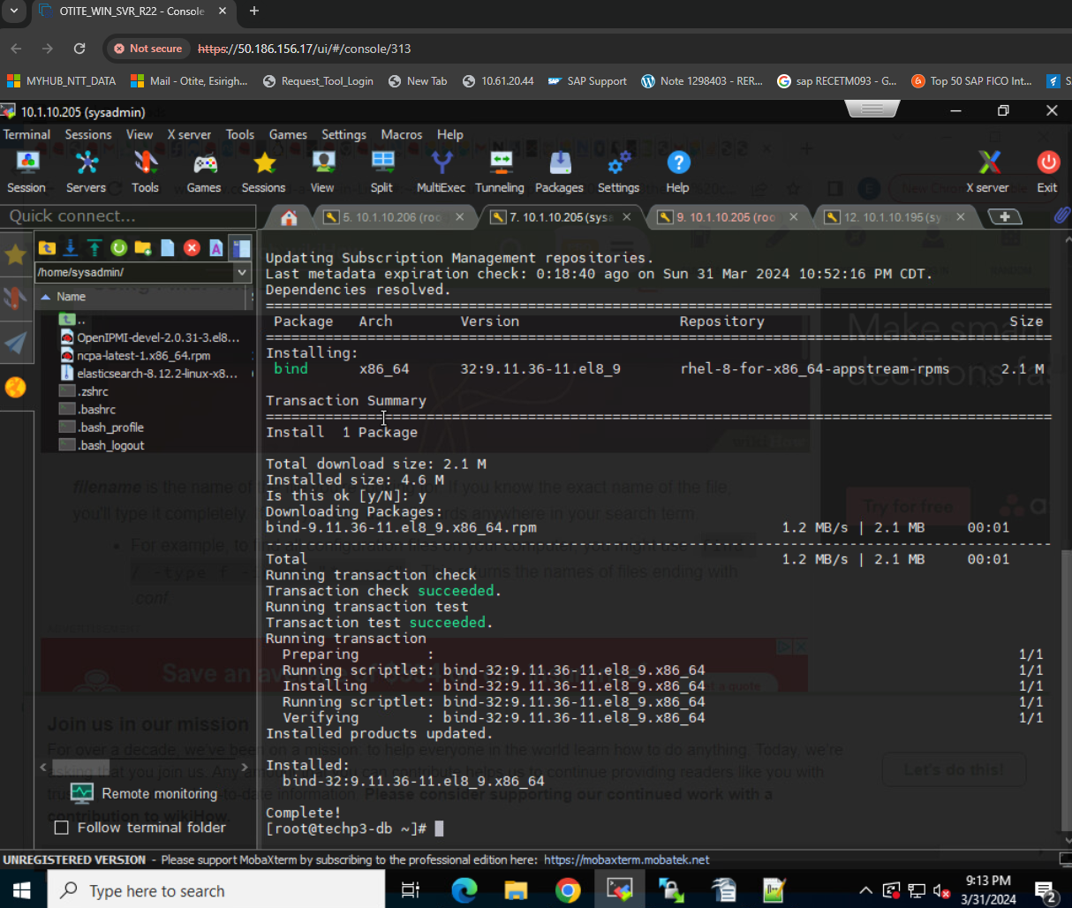
7. The BIND package provides the named service. It reads the configuration from the /etc/named and /etc/named.conf files. Once this package is installed, you can start configuring DNS.
8. Before starting the configuration, we want to go to the absolute path the acknowledge the configuration file under /etc/
9. 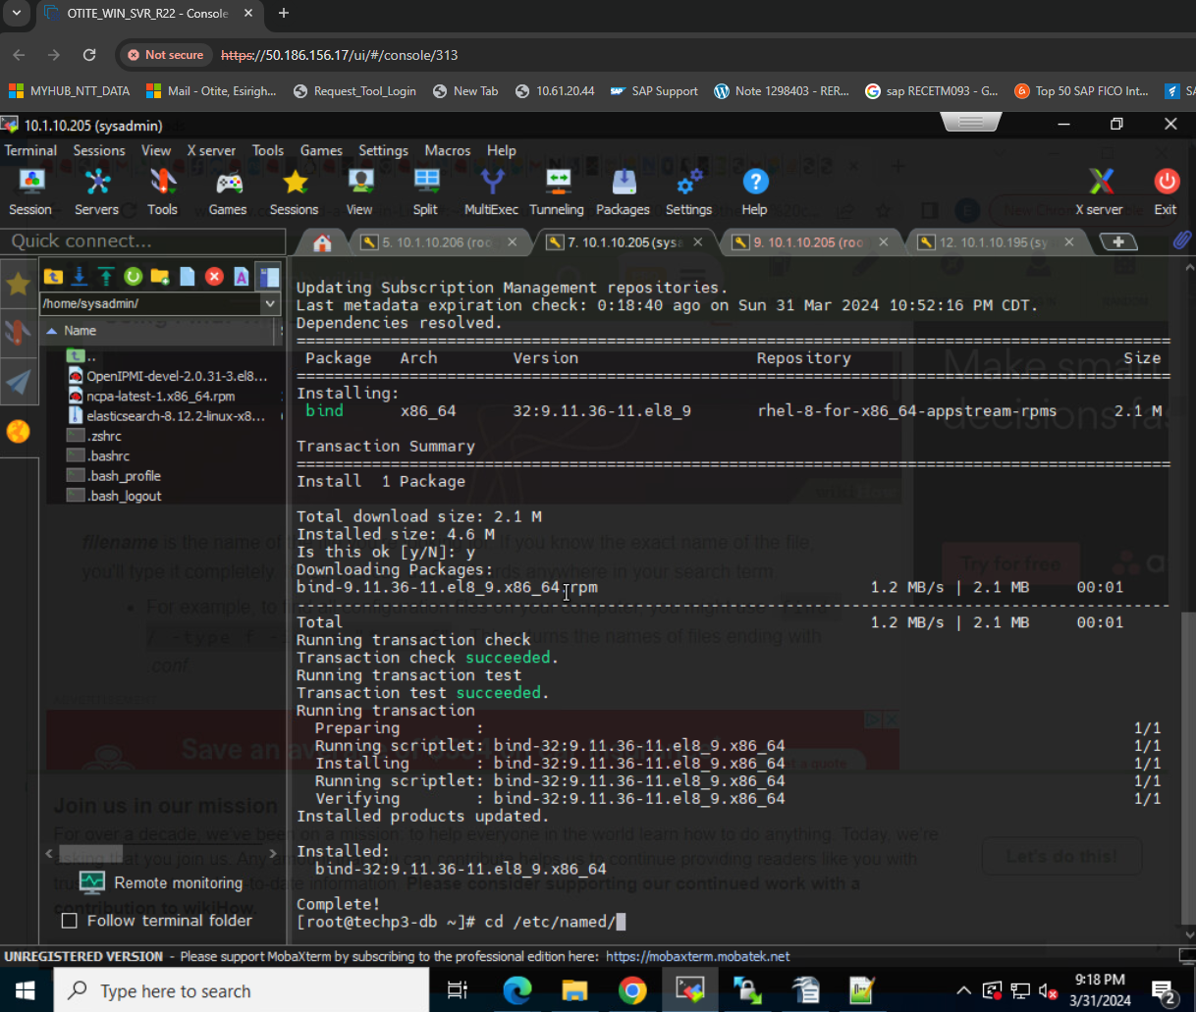
10. 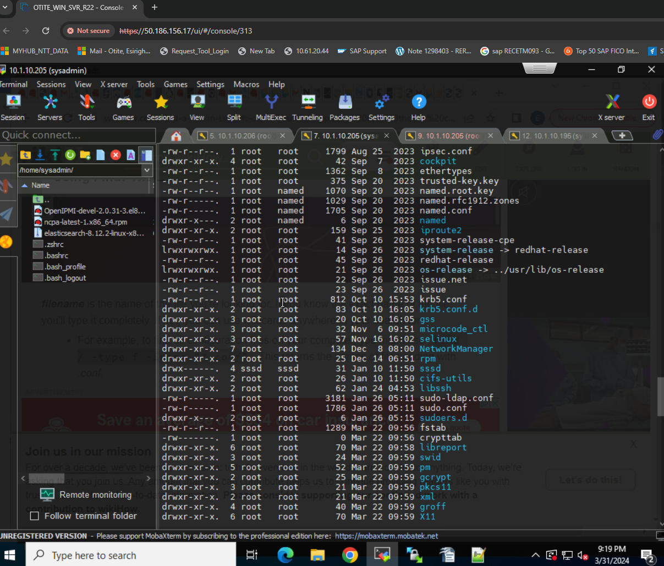
11. The package is now confirmed as installed in the /etc/ location. Now we will continue the configuration.
12. Verify some of the requirements below:
13. Part of the requirement is to have a DNS server hostname, Client hostnames 2 in number;

* DNS server hostname: techp3-db.git-gotech.net
* 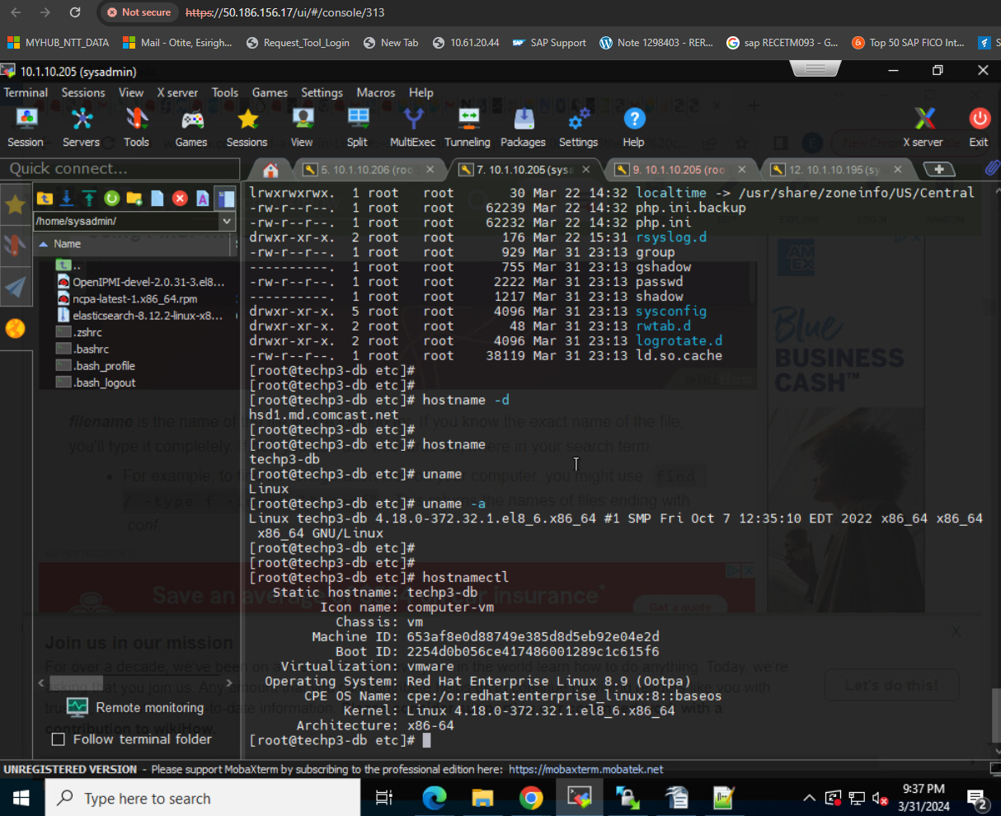
  + Using linux command “hostname -d”
    - Hsd1.md.comcast.net
  + Using linux command “hostname”
    - Techp3-db
    - Assuming same as techp3-db.git-gotech.net
* Client hostname names: yourname-webclient1. git-gotech.net
  + Wanka.git-gotech.net
* Yourname-dbclient2. git-gotech.net
  + Otite-db-nagios.git-gotech.net

1. Once successfully installed, start the DNS server using the command below:
2. # systemctl start named
3. Enable it so that it can kick in even after a reboot
4. # systemctl enable named
5. Check that the service is running
6. # systemctl status named
7. 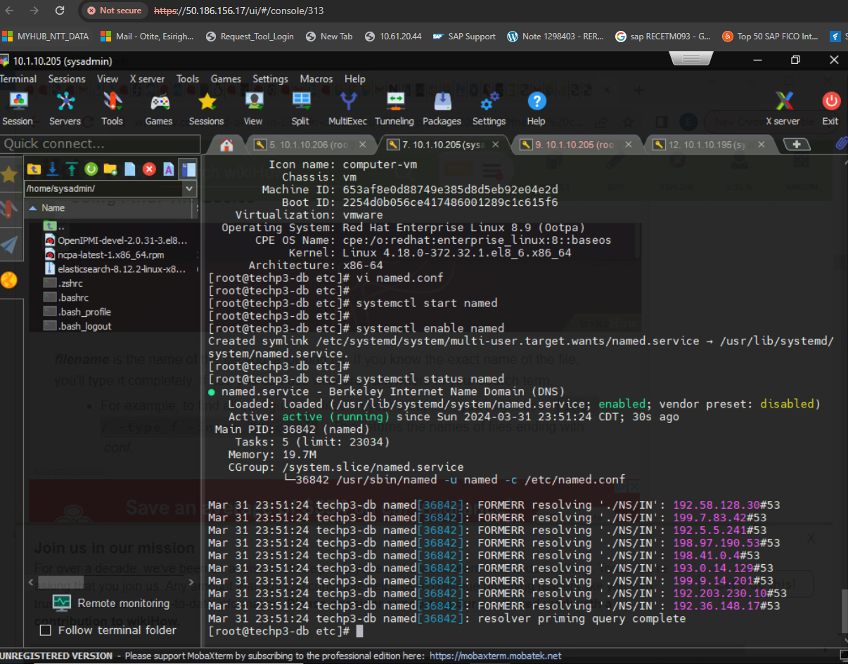
8. Create a backup file before making any changes.
9. #cp named.conf named.bak
10. 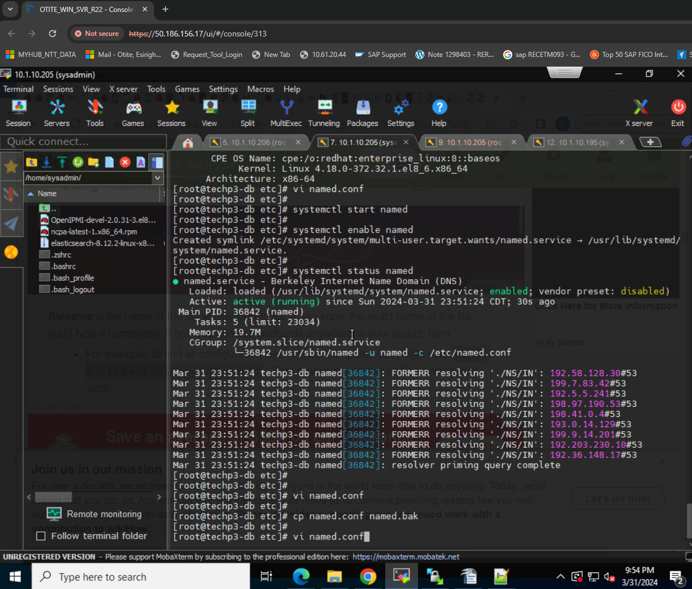
11. Once in the config file under the “options” section, ensure you comment out the lines to enable the BIND server to listen to all IPs.
12. 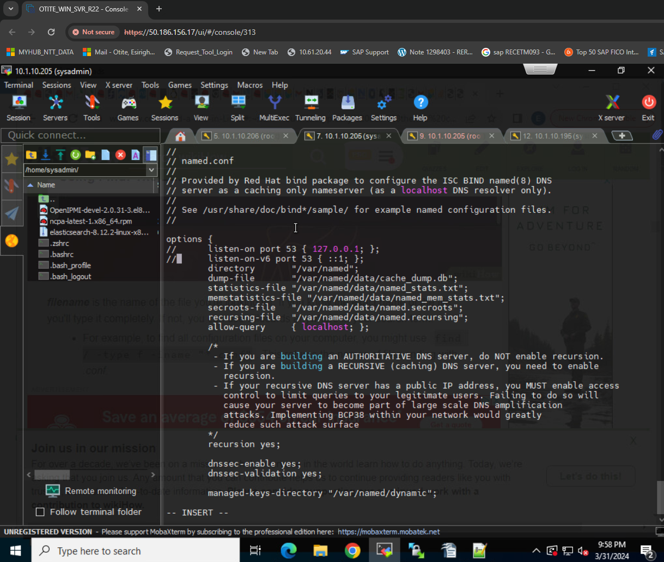
13. Additionally, locate the allow-query parameter and adjust it

according to our network subnet.

1. 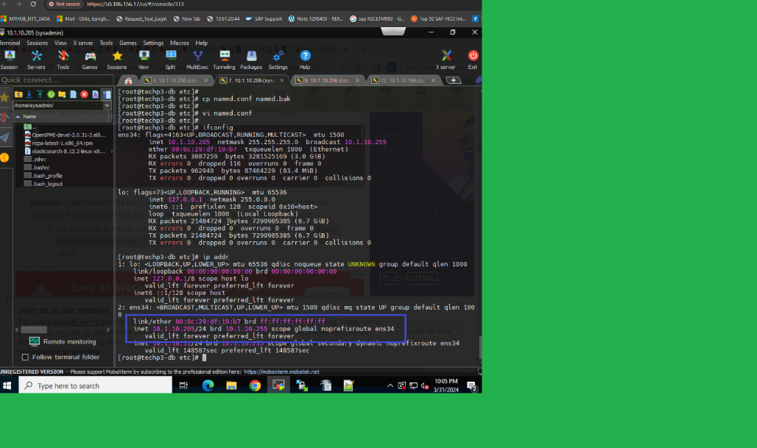
2. 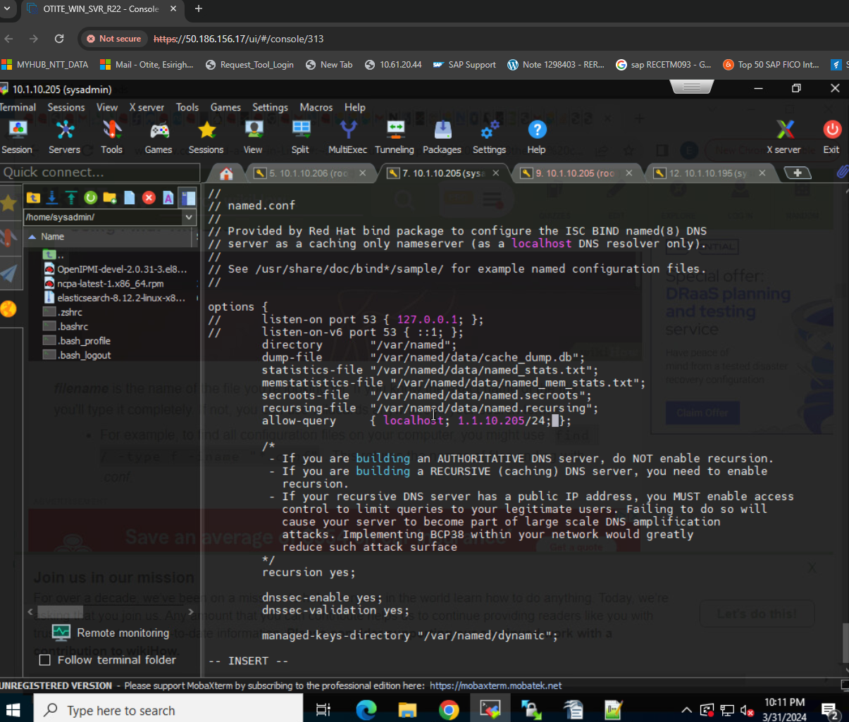
3. The setting above allows only the hosts (nameserver/main box) in the defined network to access the DNS server (nameserver) and not just any other host.
4. A forward lookup DNS zone is the one that stores the host ip address relationship. This means that when a query is conducted, it gives the IP address of the host system using the host name. In contrast the reverse DNS zone returns the Fully Qualified Name (FQDN) of the server in relation to it’s IP address. The definition of the forward and reverse lookup zones are found at the end of the “named.conf file.

Configure the /etc/named.conf file

First, add or edit the two values in the **options** field. One is the DNS server address, and the other is the **allow-query** to **any**.

[root@techp3-db ~] *# vim /etc/named.conf*

**listen**-on port 53 { 127.0.0.1; 192.168.25.132; };

allow-query { localhost; any; 10.1.10.205/24 };

Here are the values from the above file:

* **192.168.25.132** – DNS server address
* **any** – matches every IP address

**Configuration file below, I vimed in to edit:**

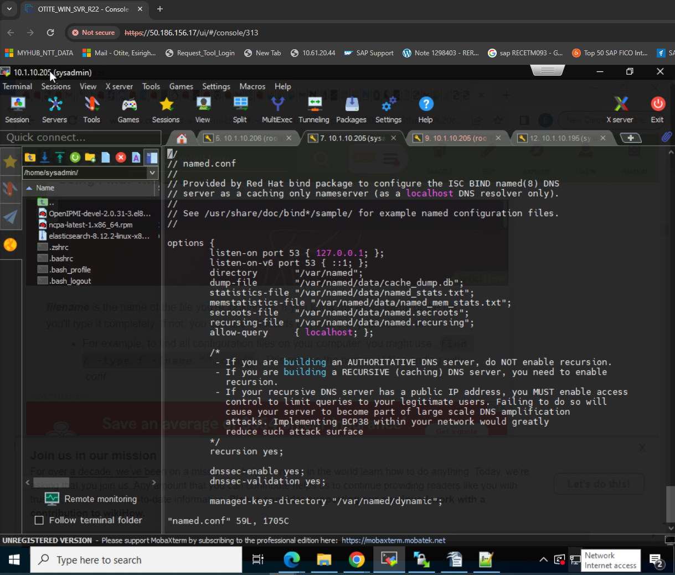

Define the forward and reverse zones

Define the forward and reverse zones in the /etc/named.conf or /etc/named.rfc1912.zones (you can define zones in either of those files). In this example, I am appending zone definition details to the /etc/named.rfc1912.zones file.

[root@techp3-db ~] *# vim /etc/named.rfc1912.zones*

  zone "techp3-db.git-gotech.net" IN { type master;

file "example.forward.zone";

allow-update { none; };

};

zone "10.1.10.195.in-addr.arpa" IN {

type master;

file "example.reverse.zone";

allow-update { none; };

};

Create forward and reverse zone files

You also need to create forward and reverse zone files in the /var/named directory.

**Note**: By default, the named.conf file includes the /var/named directory for checking zone files. Sample zone files named.localhost and named.loopback are created during the installation of the BIND package.

[root@techp3-db ~] *# vim /var/named/example.forward.zone*

*[root@techp3-db ~] # Vi tecmint.lan.db is our forward zone files*

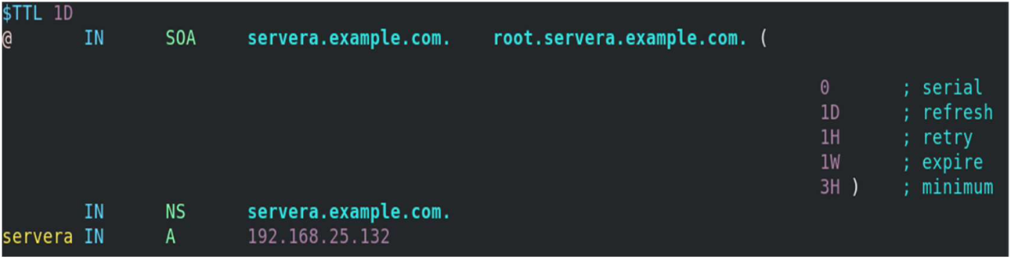

[root@techp3-db ~] *# vim /var/named/tecmint.lan.rev*

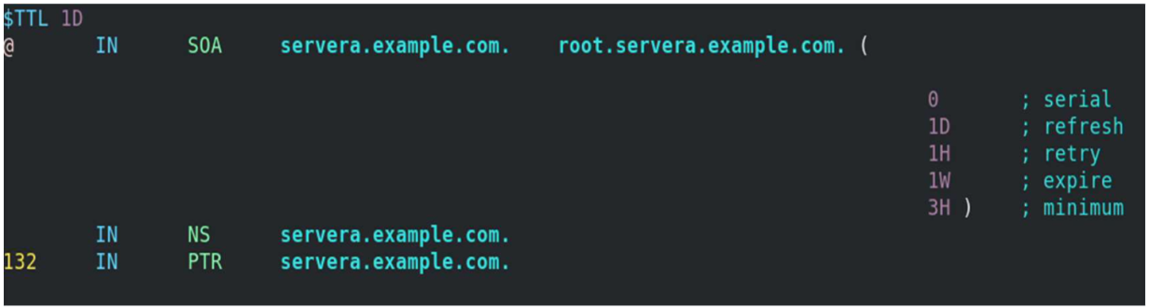

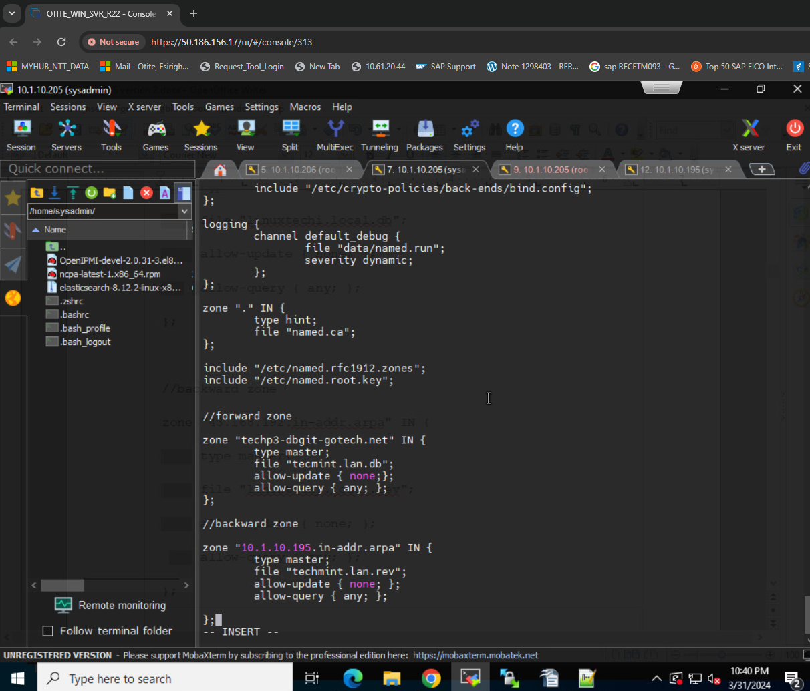

Add the nameserver IP to /etc/resolv.conf

Vi resolv.conf

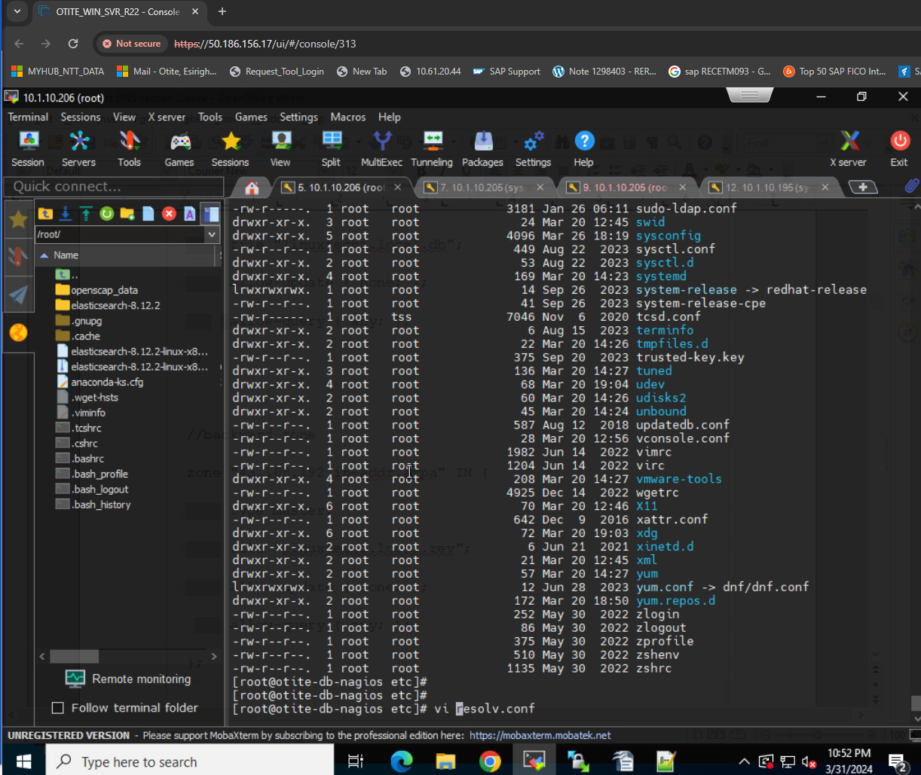

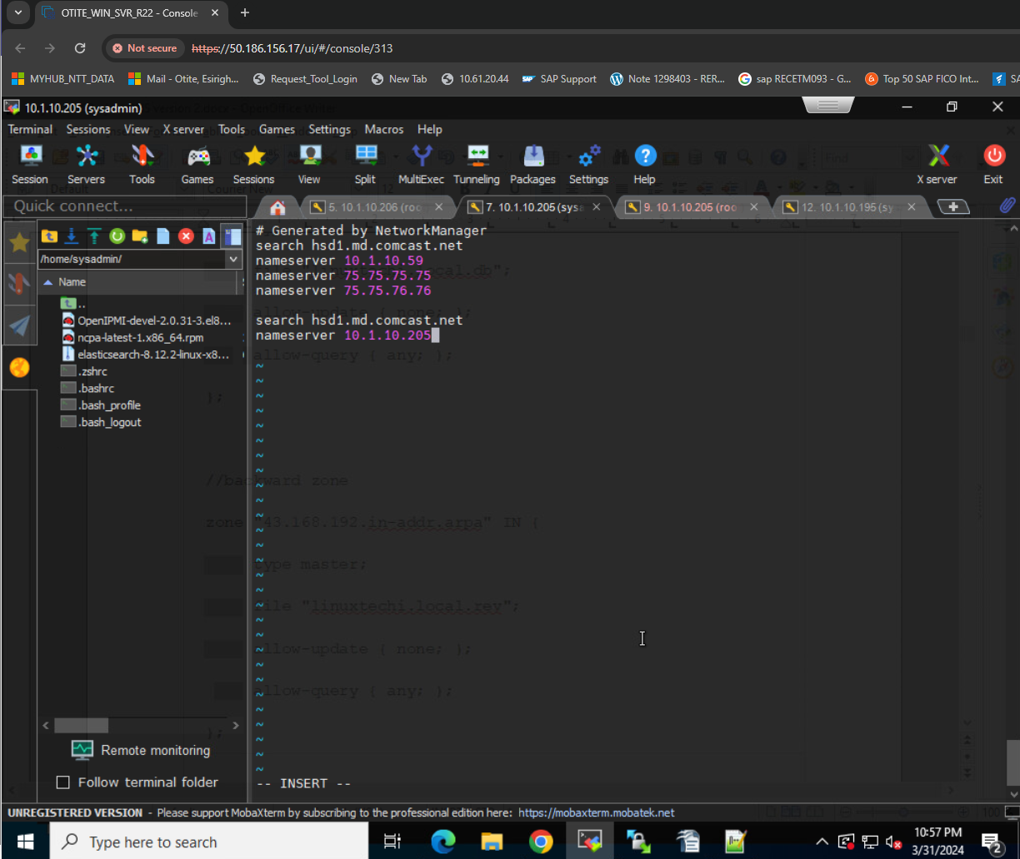

First, you must disable DNS processing by NetworkManager because it dynamically updates the /etc/resolv.conf file with DNS settings from its active connection profiles. To disable this and allow manual editing of /etc/resolv.conf, you must create a file (For example, 90-dns-none.conf), as root in the /etc/NetworkManager/conf.d/ directory that contains the following:

**[main]**

dns=none

Save the file and reload (restart) NetworkManager.

*# systemctl reload NetworkManager*

After you reload NetworkManager, it won't update /etc/resolv.conf. Now, you can manually add the nameserver's IP address to the /etc/resolv.conf file.

[root@techp3-db ~] *# vim /etc/resolv.conf*

*# Generated by NetworkManager*

search localdomain example.com

nameserver 10.1.10.195

Start/restart and enable the named service

If the named service is not running or is disabled, then start and enable it. If it is already active (running) and you made all these configurations, you need to restart the service to make changes.

[root@techp3-db ~] *# systemctl status named.service*

[root@techp3-db ~] *# systemctl start named.service*

[root@techp3-db ~] *# systemctl enable named.service*

[root@techp3-db ~] *# systemctl restart named.service*

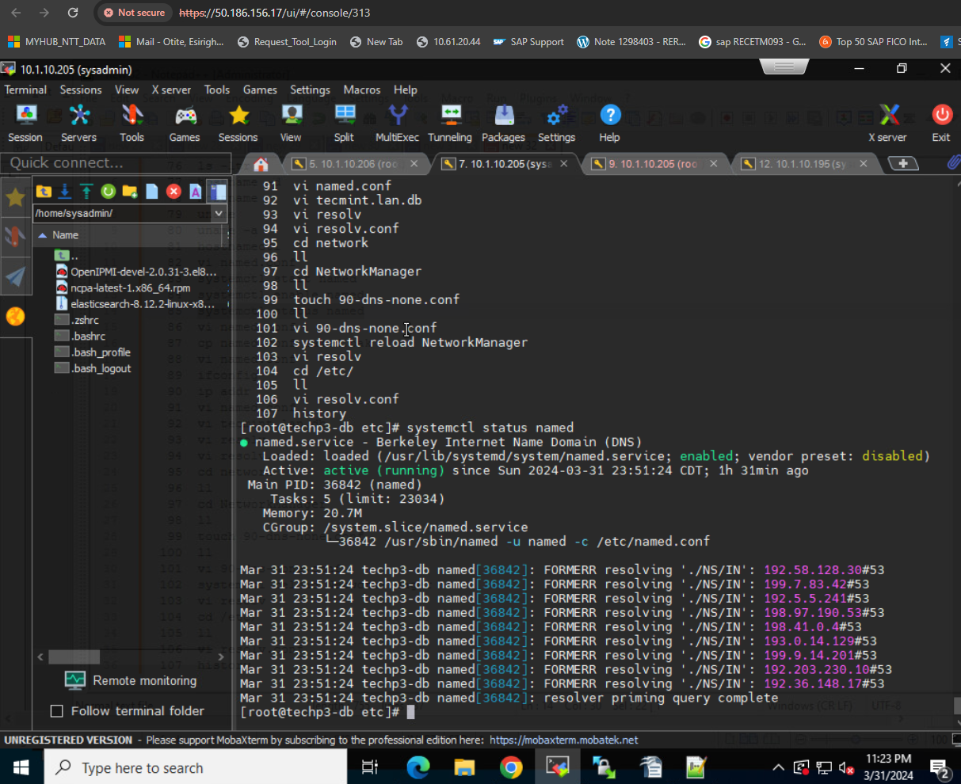

Verify the DNS name resolution

You have installed the BIND package, configured named files, created lookup zones, and restarted the service to make configurations take effect. Now use the nslookup and dig commands to check whether DNS is working properly and verify whether you are getting the intended results.

* nslookup is a program to query internet domain name servers.
* dig is a tool for interrogating DNS servers. It performs DNS lookups and displays the answers that are returned from the nameserver.

Query with nslookup

[root@wanka ~] *# nslookup techp3-db*

  Server: 8.8.8.8

Address: 8.8.8.8*#53*

Name: *techp3-db*

Address: 10.1.10.11

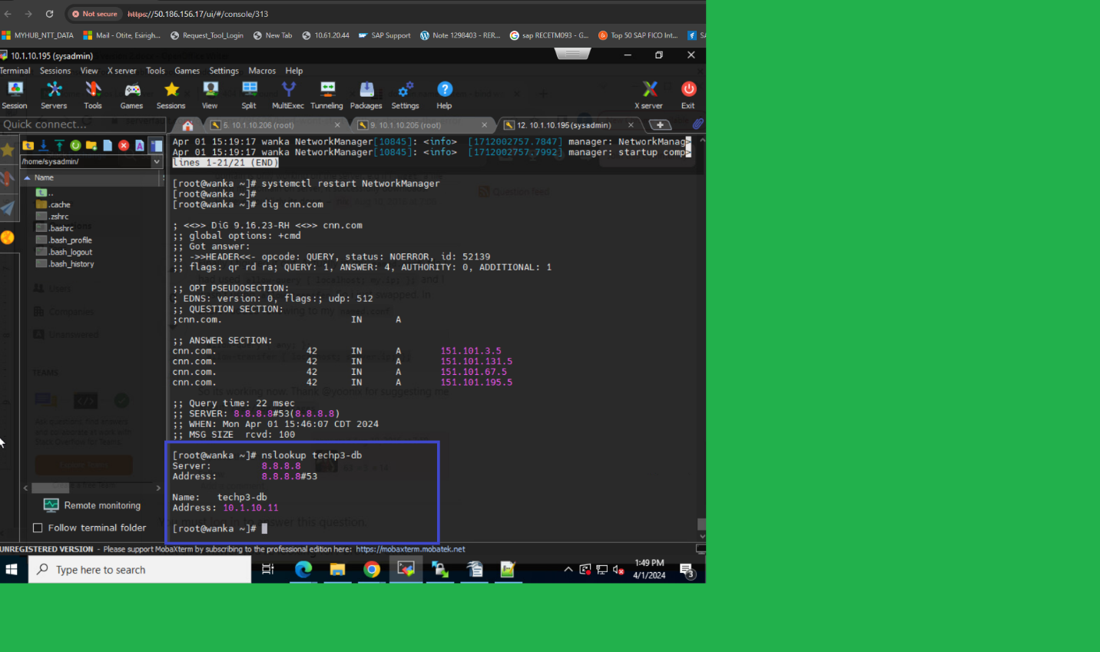

Wrap up

In this article, you learned what DNS is and how it works. Also, you now know what forward and reverse lookup zones are and how they work. You also learned how to install the BIND package, which is responsible for setting up DNS on the system and configuring the named files and lookup zones. Finally, you learned two commands, nslookup and dig, to interrogate DNS resolutions.

**Troubleshooting:**

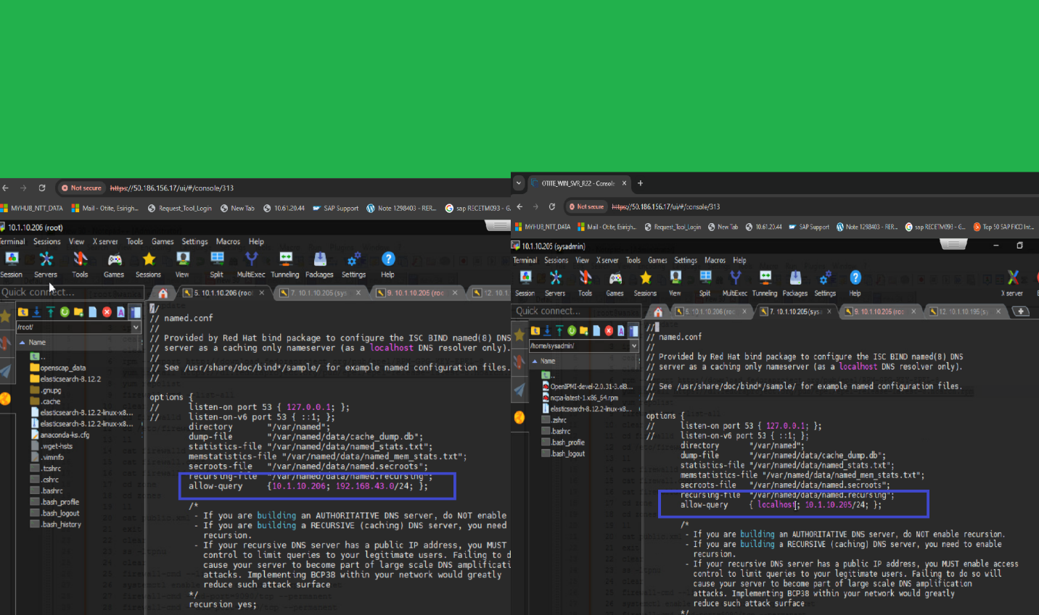

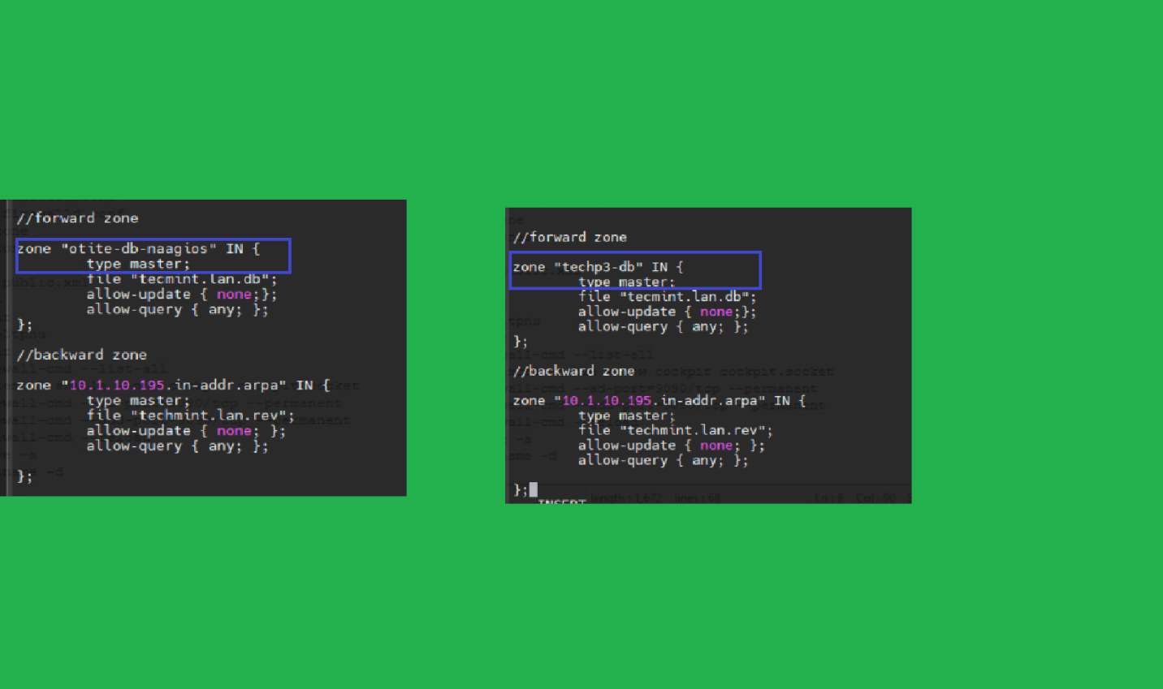

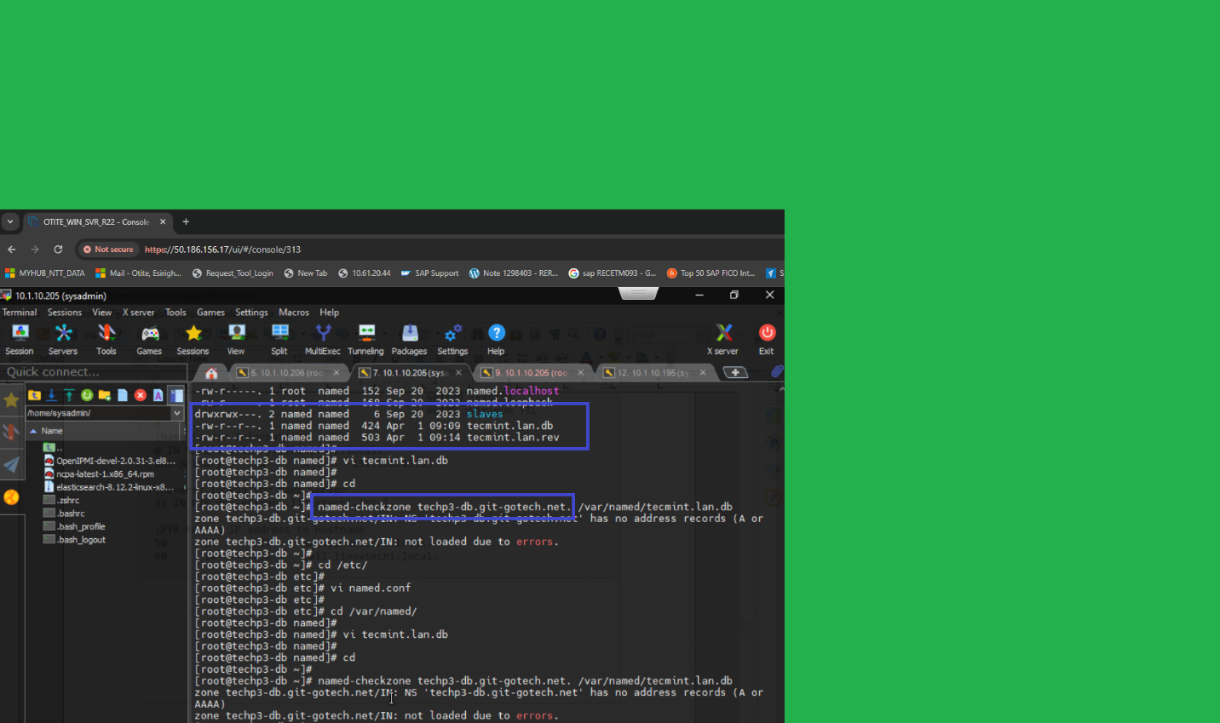

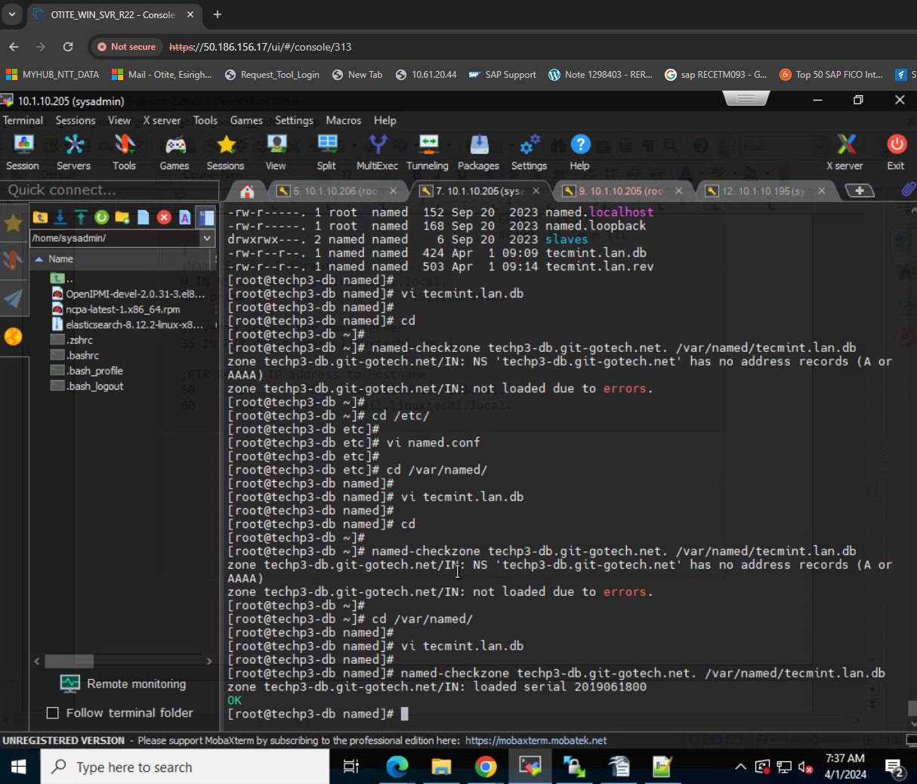

**Add services to the firewall and enable:**

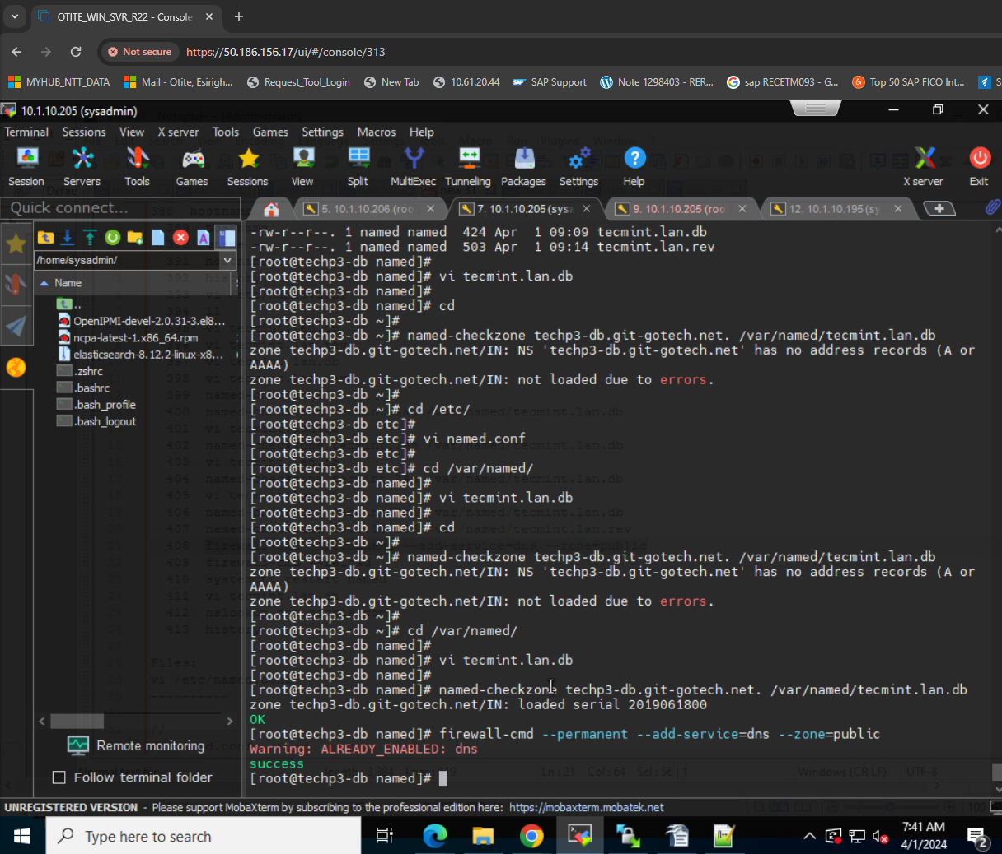

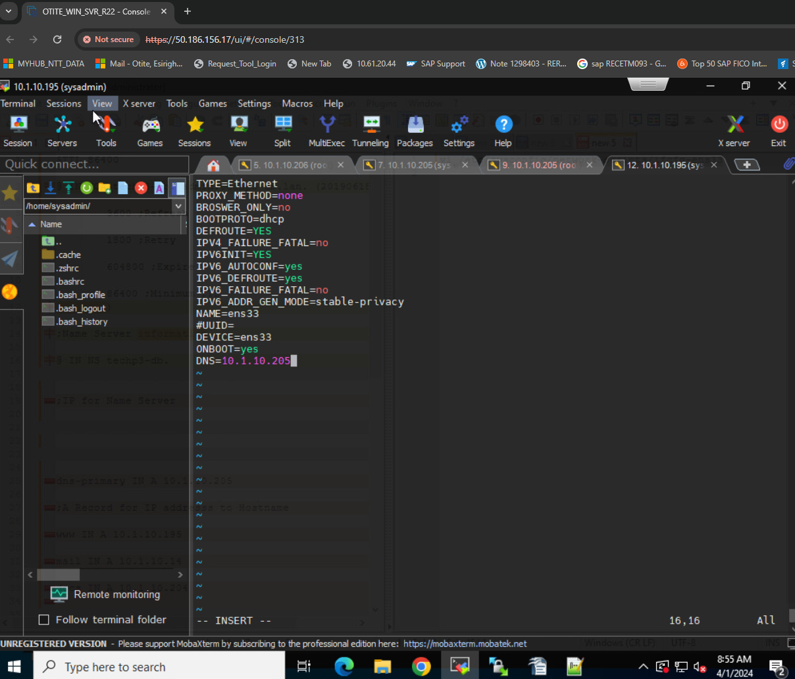

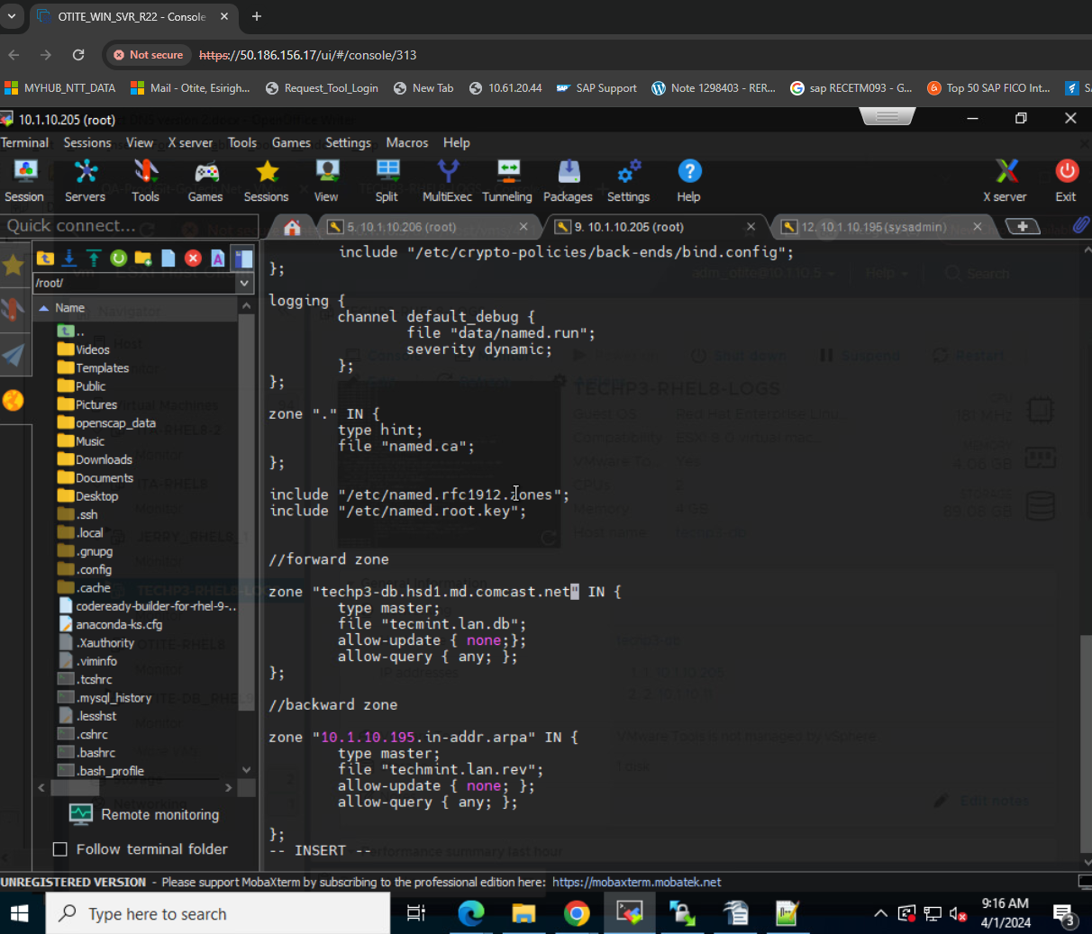

**This finally shows the DNS address:**

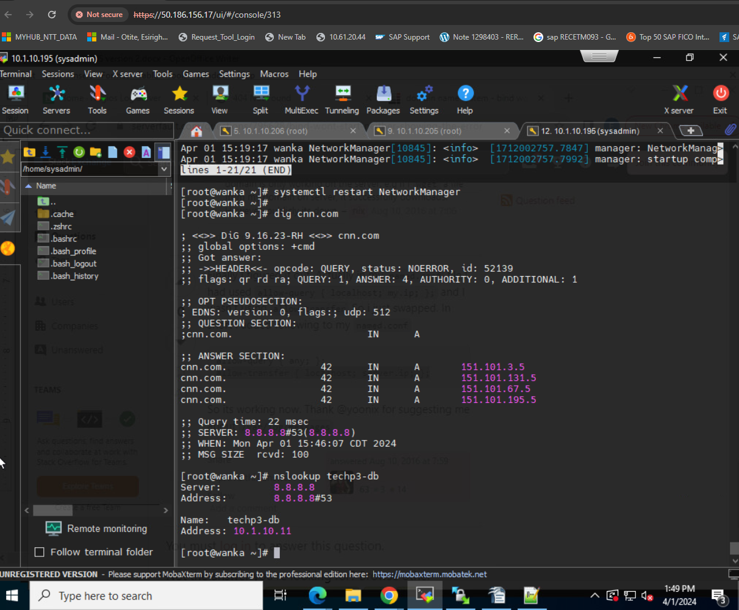



**Appendix (Extra reading):**

**As noted below *(Source: https://www.linkedin.com/pulse/linux-dns-configuration-kumari-prerna-6vzzc/)*:**

**Domain Name System (DNS) is a fundamental component of the internet, translating human-readable domain names into machine-readable IP addresses. Configuring DNS on a Linux system is crucial for seamless network communication.**

**DNS Basics:**

1. **DNS Components: DNS involves multiple components, including:**
   1. **DNS servers 🡪 DNS servers store and manage domain information**
   2. **Resolvers 🡪 while resolvers query these servers for IP addresses.**
   3. **Authoritative servers 🡪 provides the IP address**
2. **DNS Resolution Process: When a user enters a domain name, the resolver first checks the local cache. If the information is not cached, it queries DNS servers in a hierarchical order until it reaches an authoritative DNS server, which provides the IP address.**

**Linux DNS Configuration Files:**

1. **/etc/hosts:The /etc/hosts file allows mapping IP addresses to hostnames locally. While it is not a DNS configuration file, it plays a role in hostname resolution.plaintextCopy code# Example: /etc/hosts entry 127.0.0.1 localhost mymachine**
2. **/etc/resolv.conf:The /etc/resolv.conf file specifies the DNS resolver configuration, including the IP addresses of DNS servers and domain search options.plaintextCopy code# Example: /etc/resolv.conf configuration nameserver 8.8.8.8 nameserver 8.8.4.4 search example.com**

**Configuring DNS Servers on Linux:**

1. **Bind DNS Server:Bind (Berkeley Internet Name Domain) is a widely used DNS server on Linux. Configure the /etc/named.conf file to set up Bind.plaintextCopy code# Example: Bind DNS server configuration zone "example.com" { type master; file "/var/named/db.example.com"; };**
2. **dnsmasq:Dnsmasq is a lightweight DNS forwarder and DHCP server. Edit the /etc/dnsmasq.conf file to configure DNS settings.plaintextCopy code# Example: Dnsmasq configuration server=8.8.8.8 server=8.8.4.4**

**DNS Security:**

1. **DNSSEC (DNS Security Extensions):DNSSEC enhances DNS security by adding cryptographic signatures to DNS data. Enable DNSSEC in the DNS server configuration to ensure data integrity.plaintextCopy code# Example: Enabling DNSSEC in named.conf options { dnssec-enable yes; dnssec-validation yes; };**
2. **Firewall Configuration:Configure firewalls to allow DNS traffic. Open ports 53 (UDP and TCP) for DNS communication.bashCopy code# Example: Opening ports for DNS (using iptables) iptables -A INPUT -p udp --dport 53 -j ACCEPT iptables -A INPUT -p tcp --dport 53 -j ACCEPT**

**Troubleshooting DNS Issues:**

1. **Checking DNS Resolution:Use the nslookup or dig command to troubleshoot DNS resolution issues.bashCopy code# Example: Using nslookup nslookup example.com**
2. **Logs and Debugging:Review DNS server logs for errors and debugging information. Log files are typically found in /var/log.bashCopy code# Example: Checking DNS server logs tail -f /var/log/named/named.log**

**Best Practices for Linux DNS Configuration:**

1. **Use Local DNS Caching:Set up a local DNS caching server to improve response times and reduce external DNS queries.plaintextCopy code# Example: Configuring a caching DNS server in named.conf options { recursion yes; forwarders { 8.8.8.8; 8.8.4.4; }; };**
2. **Regular Updates and Monitoring:Keep DNS software up-to-date to patch security vulnerabilities. Monitor DNS server logs for any unusual activity.bashCopy code# Example: Updating Bind DNS server yum update bind**
3. **Implement Split-Horizon DNS:Use Split-Horizon DNS to provide different DNS responses based on the source of the DNS request, enhancing security and network segmentation.plaintextCopy code# Example: Split-Horizon DNS in named.conf view "internal" { match-clients { localnets; }; recursion yes; // Internal zone configurations }; view "external" { match-clients { any; }; recursion no; // External zone configurations };**

**Conclusion:**

Effectively configuring DNS on a Linux system is crucial for ensuring seamless network communication and a secure online experience. From understanding the basics to configuring DNS servers and troubleshooting, this guide provides a comprehensive overview of Linux DNS configuration. By following best practices and staying vigilant with monitoring, Linux administrators can maintain a reliable and secure DNS infrastructure.

I'm not sure you ever got a serious answer to this. All larger internal networks run some sort of DNS server. In Windows environments, it's usually a Windows server, and DNS is one of the roles that can be installed. Good practice is to have at least 2 DNS servers for redundancy. No, you wouldn't really ever want to make changes to a hosts file on any individual machines. Domain-joined machines are generally set up to register their IP address and hostname with the network's DNS server(s), so admins don't have to handle that sort of thing manually. However, as many people have pointed out, there are other types of DNS records that may be added or changed manually, and all of these would be managed on the DNS server(s) rather than by changing the hosts file on machines.

There are basically two uses of domains. The first use is to give each computer a domain name which helps you locate it on the network. Nobody should ever have to look up the IP address of a computer in the documentation since you can just use the domain name of the computer. Naturally every time you installs, change address or removes a computer you have to add or remove the entry in the DNS as well. If you are using DHCP for your client computers then such updates can happen often.

The other use is that a service gets one or more domains. This way clients can just point to a domain and don't have to look up in the documentation to find out what computer the service is running on and then look up what address that computer have. Having it all centralized on a DNS server makes it easy to move traffic from one computer to a new computer or even load balance between multiple computers. Again every time you add, move or discontinue a service you need to update the corresponding DNS entries.

These are the two primary uses if DNS. There will always be changes to a DNS zone when something changes on the network. Preferably you automate most of the changes. You set up integration to the DHCP server, visualization solution and your configuration management solution so that you don't have to do manual updates to the DNS zones and so that it is always up to date.

DNS stands for domain name service (server) all it does is assign domains to a server's IP address. That's it. You have DNS on your computer. When you connect to google.com, your local DNS tries to resolve it. If it can't, the next network up (Your CMTS) DNS server tries to resolve it and so on.

Reverse DNS is used as a security feature to protect users. If you're connecting to google.com, reverse DNS is used to verify the IP address you're connecting to is what it's supposed to be. If the table on the DNS server states 1.1.1.1 is the Google.com server, but infact you're connecting to 2.2.2.2, the connection is rejected.

I commonly have to troubleshoot hosted email problems for clients because they have an incorrectly setup PTR record.

Watch this video by Eli the Computer Guy <https://www.youtube.com/watch?v=VwpP8PUzqLw>

and

<https://www.youtube.com/watch?v=O5JZTG5xPXw>

for a good overview on DNS.

**Functionalities for maintaining DNS for ISP:**

[Internet service providers](https://phoenixnap.com/glossary/isp-definition) use a preconfigured DNS server to filter traffic. There are many reasons to change the default DNS configuration, such as:

* **Speed improvements**. A DNS maps domain names to IP addresses. Custom DNS configuration helps improve domain name resolution times, which reduces the time needed to access a website.
* **Greater security**. Specific DNS servers block malicious web pages and focus on preventing access to [unsafe websites](https://phoenixnap.com/blog/how-to-secure-a-website). Changing the DNS configuration to use such servers improves internet security and restricts exposure to online threats.
* **Customized experience**. Configure the DNS to block access to specific web pages or reroute domain names to different addresses. For example, some DNS servers help create a family-friendly environment by blocking access to unsafe or suspicious websites.
* **Privacy**. Some DNS servers log internet queries for advertising purposes. Changing the DNS configuration to a privacy-focused server enables better control over online privacy.
* **Troubleshooting**. Changing to a different DNS server is crucial in [troubleshooting DNS issues](https://phoenixnap.com/kb/dns-troubleshooting).

Step 1: Install bind DNS on CentOS 8 / RHEL 8

# dnf install bind bind-utils

# systemctl start named

# systemctl enable named

# systemctl status named

Step 2: Configure bind DNS server.

Let’s take a backup of the config file /etc/named.conf

# cp /etc/named.conf /etc/named.bak

# vim /etc/named.conf

Under the ‘Options’ section, ensure you comment out the lines indicated below to enable the Bind DNS server to listen to all IPs.

// listen-on port 53 { 127.0.0.1; };

// listen-on-v6 port 53 { ::1; };

Additionally, locate the allow-query parameter and adjust it according to your network subnet.

allow-query { localhost; 192.168.43.0/24; };

This setting allows only the hosts in the defined network to access the DNS server and not just any other host.

A forward lookup DNS zone is one that stores the host name ip address relationship. When queried, it gives the IP address of the host system using the host name. In contrast, the reverse DNS zone returns the Fully Qualified Domain Name (FQDN) of the server in relation to it’s IP address.

To define the reverse and forward lookup zones, copy and paste the following configuration at the end of /etc/named.conf

//forward zone

zone "linuxtechi.local" IN {

type master;

file "linuxtechi.local.db";

allow-update { none; };

allow-query { any; };

};

//backward zone

zone "43.168.192.in-addr.arpa" IN {

type master;

file "linuxtechi.local.rev";

allow-update { none; };

allow-query { any; };

};

After saving, exit the /etc/named.conf configuration file.

Step 3: Create a forward DNS zone file for the domain

Create a forward DNS zone file for domain linuxtechi.local as shown below and add the following content

[root@dns-primary ~]# vim /var/named/linuxtechi.local.db

$TTL 86400

@ IN SOA dns-primary.linuxtechi.local. admin.linuxtechi.local. (

2020011800 ;Serial

3600 ;Refresh

1800 ;Retry

604800 ;Expire

86400 ;Minimum TTL

)

;Name Server Information

@ IN NS dns-primary.linuxtechi.local.

;IP Address for Name Server

dns-primary IN A 10.1.10.206

;Mail Server MX (Mail exchanger) Record

linuxtechi.local. IN MX 10 mail.linuxtechi.local.

;A Record for the following Host name

www IN A 192.168.43.50

mail IN A 192.168.43.60

;CNAME Record

ftp IN CNAME www.linuxtechi.local.

Let’s define some of the parameters indicated in the configuration file:

• TTL: This is short for Time-To-Live. TTL is the duration of time (or hops) that a packet exists in a network before finally being discarded by the router.

• IN: This implies the Internet.

• SOA: This is short for the Start of Authority. Basically, it defines the authoritative name server, in this case, dns-primary.linuxtechi.local and contact information – admin.linuxtechi.local

• NS: This is short for Name Server.

• A: This is an A record. It points to a domain/subdomain name to the IP Address

• Serial: This is the attribute used by the DNS server to ensure that contents of a specific zone file are updated.

• Refresh: Defines the number of times that a slave DNS server should transfer a zone from the master.

• Retry: Defines the number of times that a slave should retry a non-responsive zone transfer.

• Expire: Specifies the duration a slave server should wait before responding to a client query when the Master is unavailable.

• Minimum: This is responsible for setting the minimum TTL for a zone.

• MX: This is the Mail exchanger record. It specifies the mail server receiving and sending emails

• CNAME: This is the Canonical Name. It maps an alias domain name to another domain name.

• PTR: Short for Pointer, this attributes resolves an IP address to a domain name, opposite to a domain name.

Step 4: Create a reverse DNS zone file for the domain

Similarly, we need to create a file for reverse DNS lookups. Paste the following content in the file:

[root@dns-primary ~]# vim /var/named/linuxtechi.local.rev

$TTL 86400

@ IN SOA dns-primary.linuxtechi.local. admin.linuxtechi.local. (

2020011800 ;Serial

3600 ;Refresh

1800 ;Retry

604800 ;Expire

86400 ;Minimum TTL

)

;Name Server Information

@ IN NS dns-primary.linuxtechi.local.

dns-primary IN A 10.1.10.206

;Reverse lookup for Name Server

35 IN PTR dns-primary.linuxtechi.local.

;PTR Record IP address to Hostname

50 IN PTR www.linuxtechi.local.

60 IN PTR mail.linuxtechi.local.

Next, assign the necessary file permissions to the two configuration files.

# chown named:named /var/named/linuxtechi.local.db

# chown named:named /var/named/linuxtechi.local.rev

To confirm that the DNS zone lookup files are free from any syntactical errors, run the commands shown:

# named-checkconf

# named-checkzone linuxtechi.local /var/named/linuxtechi.local.db

# named-checkzone 10.1.10.206 /var/named/linuxtechi.local.rev

If there are no errors, you should get the output shown:

For the changes to be reflected in the system, restart the Bind DNS server

# systemctl restart named

For client systems to access the system we need to add the DNS service on the firewall and thereafter reload the firewall.

# firewall-cmd --add-service=dns --zone=public --permanent

# firewall-cmd --reload

Step 5: Test the Bind DNS server from a client system

Having finalized the configuration on the DNS server, let’s head out to a client machine and perform a few tests.

On a client machine ( CentOS 8 / RHEL 8), open the /etc/resolv.conf file and edit the following parameter:

nameserver 10.1.10.206

As always, save & close the configuration file.

Lastly, you need to append the Bind DNS server’s IP address to the /etc/sysconfig/network-scripts/ifcfg-enp0s3 file as shown.

Save and close the config file and then restart the network manager service to make above change into the effect,

# systemctl restart NetworkManager

Using the nslookup command test the Bind DNS server as shown:

# nslookup dns-primary.linuxtechi.local

# nslookup mail.linuxtechi.local

# nslookup www.linuxtechi.local

# nslookup ftp.linuxtechi.local

# nslookup 10.1.10.206

The output from the nslookup command confirms that the forward DNS lookup is working as expected.

Moreover, you can also use the dig command as shown

# dig dns-primary.linuxtechi.local

To perform a reverse DNS lookup, use the dig command as shown:

# dig -x 10.1.10.206

Perfect! The reverse DNS lookup is also working as we would expect.

Appendix:

388 hostname -d

389 hostname

390 uname -a

391 hostnamectl

392 history

393 vi /etc/named.conf

394 ll

395 vi tecmint.lan.db

396 vi tecmint.lan.rev

397 vi tecmint.lan.db

398 vi tecmint.lan.rev

399 named-checkconf

400 named-checkzone tecmint.lan /var/named/tecmint.lan.db

401 vi tecmint.lan.db

402 named-checkzone tecmint.lan /var/named/tecmint.lan.db

403 vi tecmint.lan.db

404 named-checkzone tecmint.lan /var/named/tecmint.lan.db

405 vi tecmint.lan.db

406 named-checkzone tecmint.lan /var/named/tecmint.lan.db

407 named-checkzone 10.1.10.206 /var/named/tecmint.lan.rev

408 firewall-cmd --permanent --add-service=dns --zone=public

409 firewall-cmd --reload

410 systemctl restart named

411 vi tecmint.lan.db

412 nslookup dns.google.com

413 history

Files:

vi /etc/named.conf

----------

//

// named.conf

//

// Provided by Red Hat bind package to configure the ISC BIND named(8) DNS

// server as a caching only nameserver (as a localhost DNS resolver only).

//

// See /usr/share/doc/bind*/sample/ for example named configuration files.

//

options {

// listen-on port 53 { 127.0.0.1; };

// listen-on-v6 port 53 { ::1; };

directory "/var/named";

dump-file "/var/named/data/cache_dump.db";

statistics-file "/var/named/data/named_stats.txt";

memstatistics-file "/var/named/data/named_mem_stats.txt";

secroots-file "/var/named/data/named.secroots";

recursing-file "/var/named/data/named.recursing";

allow-query {10.1.10.206; 192.168.43.0/24; };

/*

- If you are building an AUTHORITATIVE DNS server, do NOT enable recursion.

- If you are building a RECURSIVE (caching) DNS server, you need to enable

recursion.

- If your recursive DNS server has a public IP address, you MUST enable access

control to limit queries to your legitimate users. Failing to do so will

cause your server to become part of large scale DNS amplification

attacks. Implementing BCP38 within your network would greatly

reduce such attack surface

*/

recursion yes;

dnssec-enable yes;

dnssec-validation yes;

managed-keys-directory "/var/named/dynamic";

pid-file "/run/named/named.pid";

session-keyfile "/run/named/session.key";

/* https://fedoraproject.org/wiki/Changes/CryptoPolicy */

include "/etc/crypto-policies/back-ends/bind.config";

};

logging {

channel default_debug {

file "data/named.run";

severity dynamic;

};

};

zone "." IN {

type hint;

file "named.ca";

};

include "/etc/named.rfc1912.zones";

include "/etc/named.root.key";

//forward zone

zone "otite-db-naagios" IN {

type master;

file "tecmint.lan.db";

allow-update { none;};

allow-query { any; };

};

//backward zone

zone "10.1.10.195.in-addr.arpa" IN {

type master;

file "techmint.lan.rev";

allow-update { none; };

allow-query { any; };

};

----------

vi tecmint.lan.db

---

---

vi tecmint.lan.rev

-----Internet Articles----

Introduction

DNS configuration sets up a Domain Name System server to translate domain names (URLs) into IP addresses. The configuration helps manage the DNS records for domains.

Knowing how to configure a DNS server is essential for any network administrator. The steps to configure a DNS differs depending on the operating system.

This article shows how to configure DNS on a Windows, macOS, and Linux machine.

Prerequisites

• A stable internet connection.

• Access to an account with administrator privileges.

• Access to the command line/terminal.

**How to Setup DNS Server (Bind) on CentOS 8 / RHEL8**

Last Updated: October 25, 2020 by [Pradeep Kumar](https://www.linuxtechi.com/author/pradeep/)

Developed in the 80’s by students at Berkeley University,**BIND** (**Berkeley Internet Name Domain**) is an open-source **DNS server** that provides DNS services on Linux distributions. So, what is a DNS server? A **DNS** server is a service that helps to resolve a fully qualified domain name (**FQDN**) into an IP address and additionally, perform a reverse translation- translation of an IP address to a user-friendly domain name.

Why is name resolution important? Well, computers locate services on servers using IP addresses. However, IP addresses are not as user-friendly as domain names, and it would be a big headache trying to remember each IP address that is associated with every domain name. A DNS server steps in and helps to resolve these domain names to computer IP addresses.

This guide walks you through the process of setting up a DNS bind server on CentOS 8 / RHEL 8.

**Lab setup:**

* Server:            Rhel 8 (minimal server)
* IP address:    10.1.10.206
* Host Name:   otite-db-nagios
* Domain:         git-gotech

Let’s now hit the ground running with the configuration of the DNS bind server.

1. Advertisement: 0:30

39

**Step 1: Install bind DNS on CentOS 8 / RHEL 8**

We begin with the installation of the bind and bind-utils package. These packages constitutes dns server and its utilities responsible for querying name servers or DNS servers.

Execute the command:

# dnf install bind bind-utils

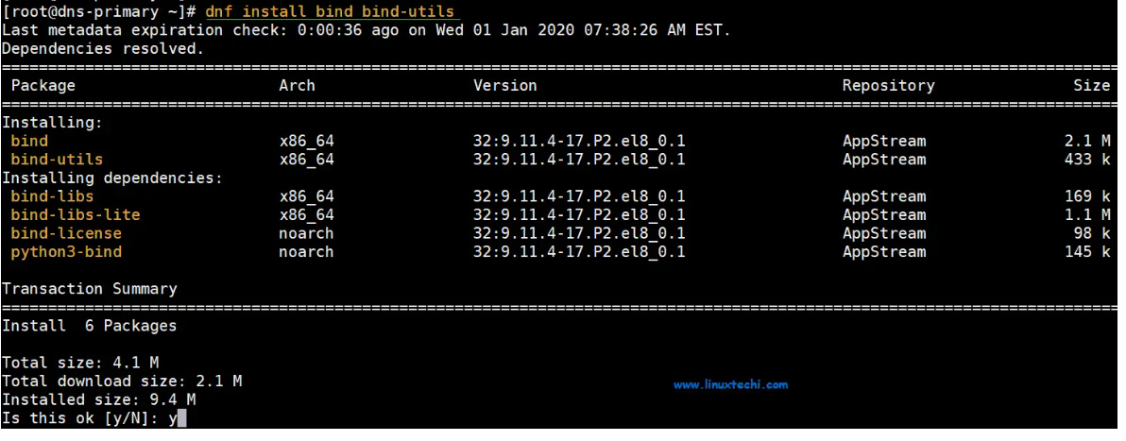

Once successfully installed, start the DNS server using the command below:

# systemctl start named

Next, enable it so that it can kick in even after a reboot.

# systemctl enable named

Just to be sure that the service is running as expected, check its status.

# systemctl status named

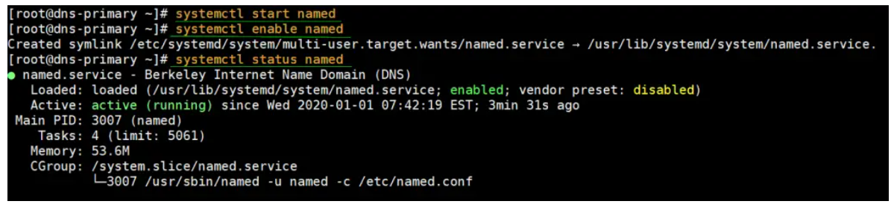

Great, the DNS server is running just perfectly. Now let’s jump into configuring the Bind DNS server.

**Step 2:  Configure bind DNS server.**

Usually, best practice recommends making a backup of a configuration file before making any changes. This is so that should anything go wrong, we can always revert to the original unedited file. And it’s no different here.

Let’s take a backup of the config file  /etc/named.conf

# cp /etc/named.conf  /etc/named.bak

Now go ahead and open the file using your preferred text editor. In this case, we’re using vim editor.

# vim /etc/named.conf

Under the ‘**Options**’ section, ensure you comment out the lines indicated below to enable the Bind DNS server to listen to all IPs.

// listen-on port 53 { 127.0.0.1; };

// listen-on-v6 port 53 { ::1; };

Additionally, locate the allow-query parameter and adjust it according to your network subnet.

allow-query { localhost; 192.168.43.0/24; };

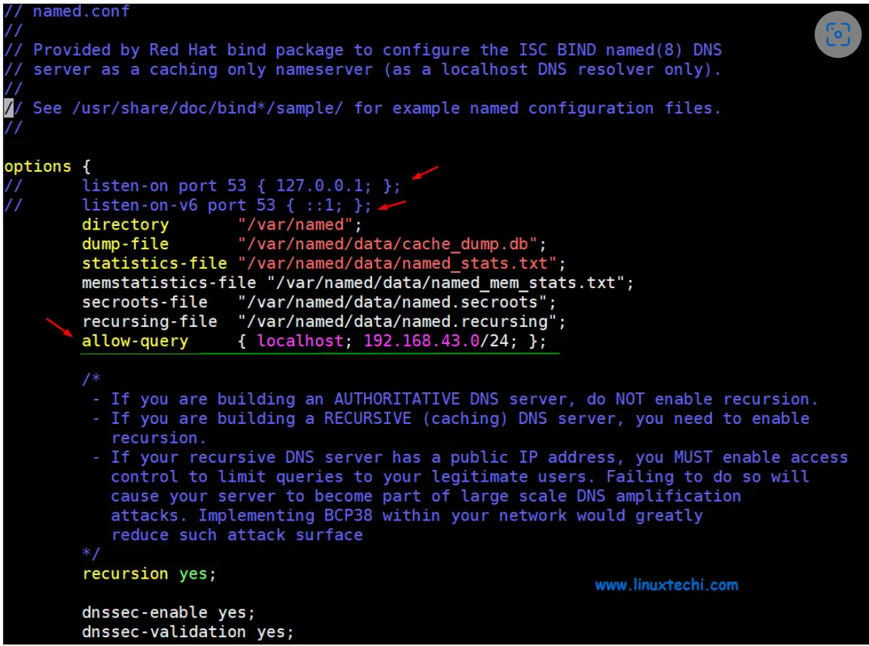

This setting allows only the hosts in the defined network to access the DNS server and not just any other host.

A**forward lookup DNS zone** is one that stores the host name ip address relationship. When queried, it gives the IP address of the host system using the host name. In contrast, the reverse**DNS zone** returns the Fully Qualified Domain Name (FQDN) of the server in relation to it’s IP address.

To define the reverse and forward lookup zones, copy and paste the following configuration at the end of **/etc/named.conf**

//forward zone

zone "linuxtechi.local" IN {

     type master;

     file "linuxtechi.local.db";

     allow-update { none; };

     allow-query { any; };

};

//backward zone

zone "43.168.192.in-addr.arpa" IN {

     type master;

     file "linuxtechi.local.rev";

     allow-update { none; };

    allow-query { any; };

};

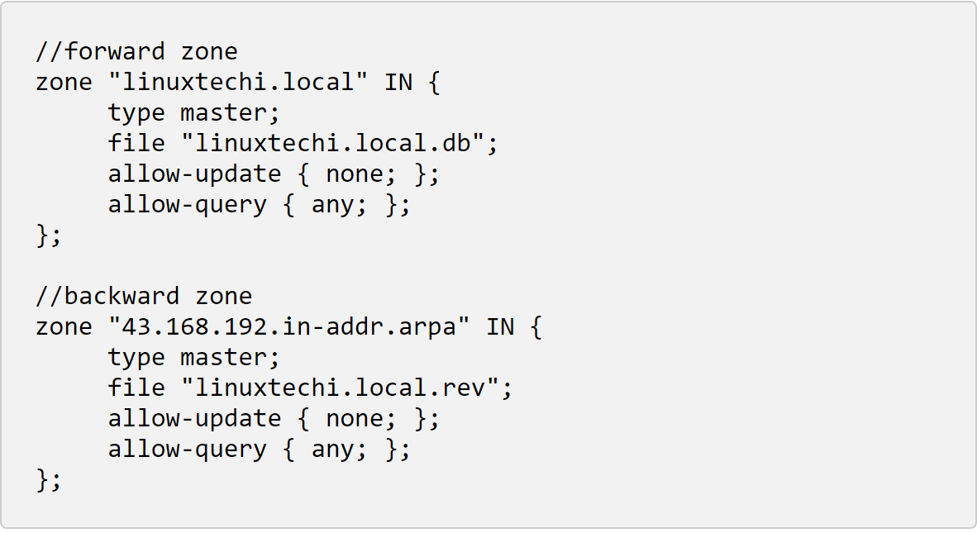

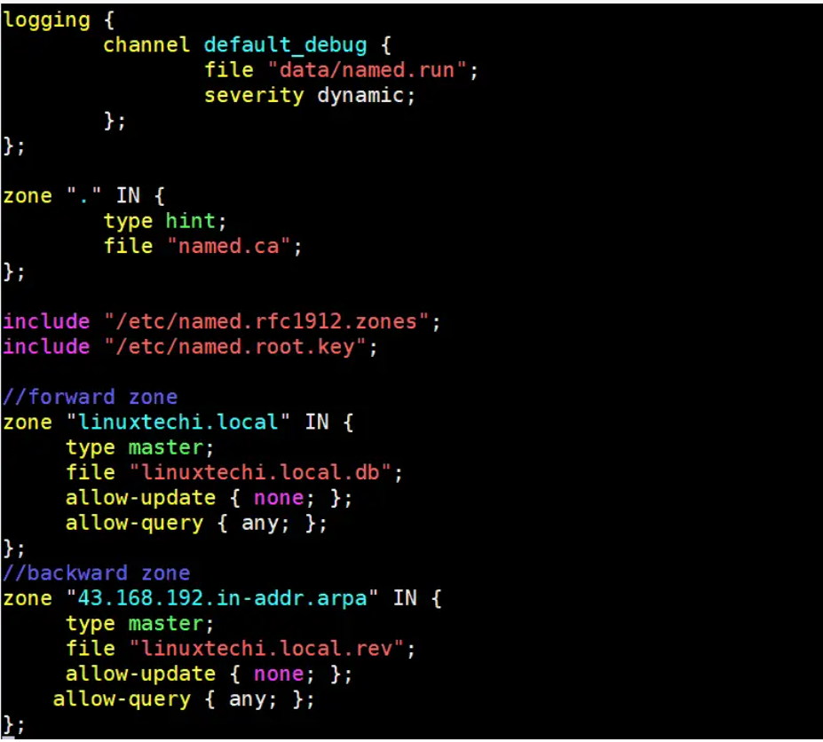

* **type**: Stipulates the role of the server for a particular zone. the attribute ‘master’ implies that this is an authoritative server.
* **file**: Points to the forward / reverse zone file of the domain.
* **allow-update**: This attribute defined the host systems which are permitted to forward Dynamic DNS updates. In this case, we don’t have any.

After saving, exit the /etc/named.conf configuration file.

**Step 3: Create a forward DNS zone file for the domain**

Create a forward DNS zone file for domain linuxtechi.local as shown below and add the following content

[root@dns-primary ~]# vim /var/named/linuxtechi.local.db

$TTL 86400

@ IN SOA dns-primary.linuxtechi.local. admin.linuxtechi.local. (

                                                2020011800 ;Serial

                                                3600 ;Refresh

                                                1800 ;Retry

                                                604800 ;Expire

                                                86400 ;Minimum TTL

)

;Name Server Information

@ IN NS dns-primary.linuxtechi.local.

;IP Address for Name Server

dns-primary IN A 10.1.10.206

;Mail Server MX (Mail exchanger) Record

linuxtechi.local. IN MX 10 mail.linuxtechi.local.

;A Record for the following Host name

www  IN   A   192.168.43.50

mail IN   A   192.168.43.60

;CNAME Record

ftp  IN   CNAME www.linuxtechi.local.

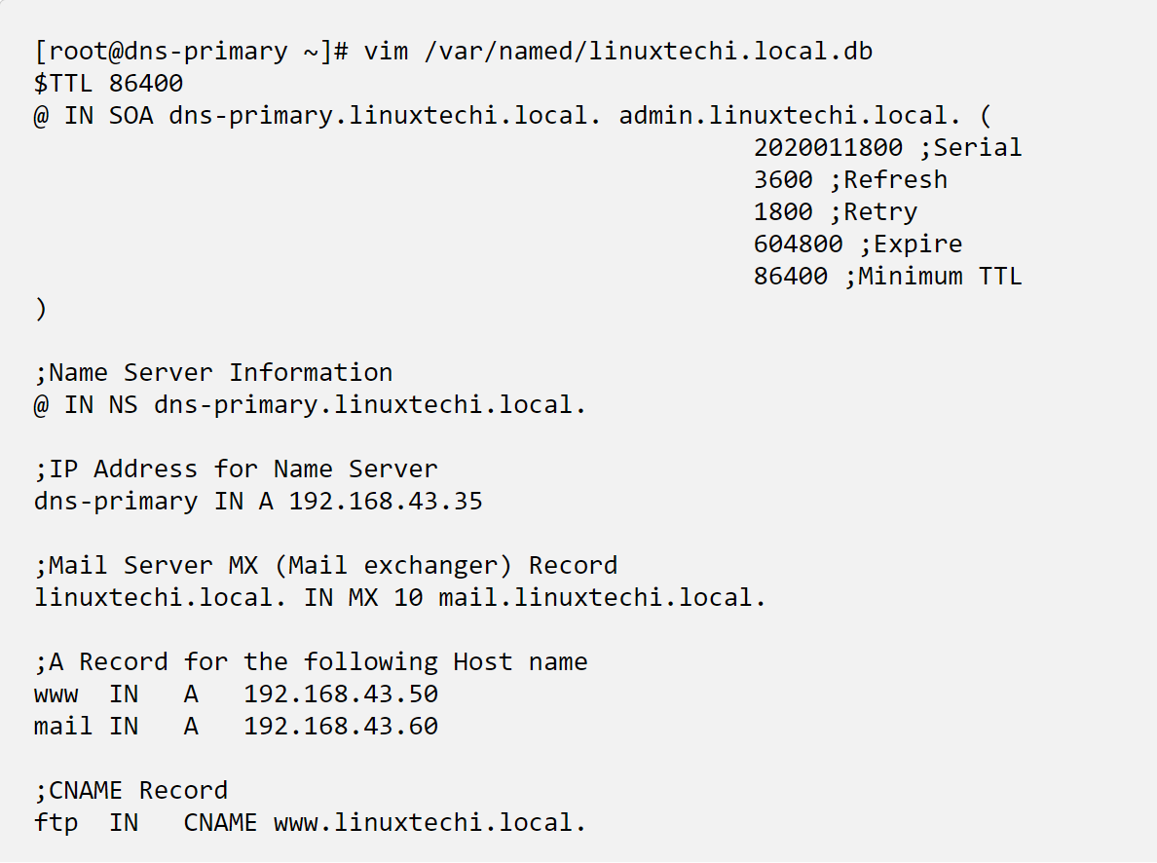

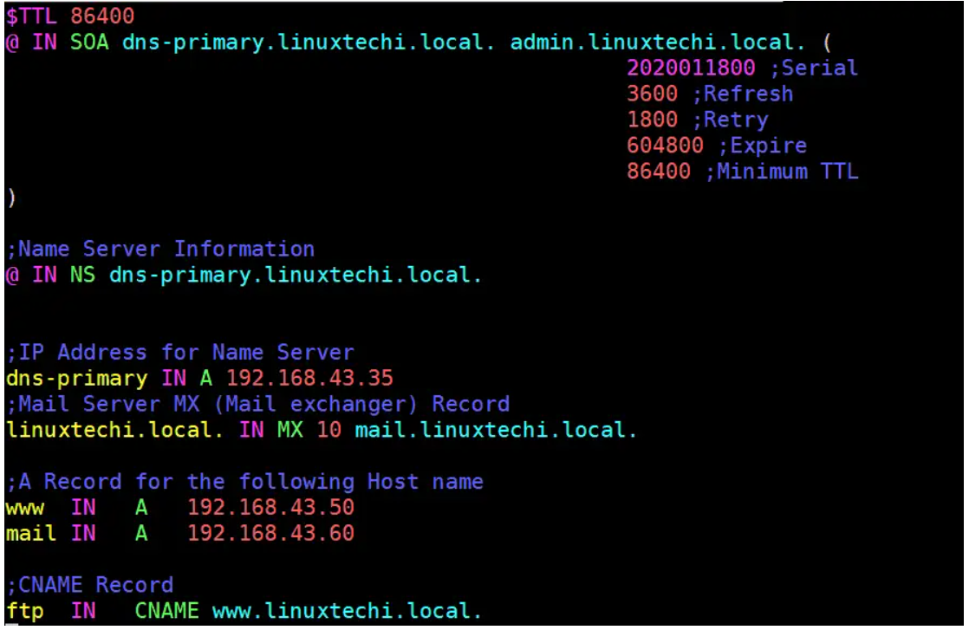

Let’s define some of the parameters indicated in the configuration file:

* **TTL**: This is short for Time-To-Live. TTL is the duration of time (or hops) that a packet exists in a network before finally being discarded by the router.
* **IN**: This implies the Internet.
* **SOA**: This is short for the Start of Authority. Basically, it defines the authoritative name server, in this case, dns-primary.linuxtechi.local and contact information – admin.linuxtechi.local
* **NS**: This is short for Name Server.
* **A**: This is an A record. It points to a domain/subdomain name to the IP Address
* **Serial**: This is the attribute used by the DNS server to ensure that contents of a specific zone file are updated.
* **Refresh**: Defines the number of times that a slave DNS server should transfer a zone from the master.
* **Retry**: Defines the number of times that a slave should retry a non-responsive zone transfer.
* **Expire**: Specifies the duration a slave server should wait before responding to a client query when the Master is unavailable.
* **Minimum**: This is responsible for setting the minimum TTL for a zone.
* **MX**: This is the Mail exchanger record. It specifies the mail server receiving and sending emails
* **CNAME**: This is the Canonical Name. It maps an alias domain name to another domain name.
* **PTR**: Short for Pointer, this attributes resolves an IP address to a domain name, opposite to a domain name.

**Step 4: Create a reverse DNS zone file for the domain**

Similarly, we need to create a file for reverse DNS lookups. Paste the following content in the file:

[root@dns-primary ~]# vim /var/named/linuxtechi.local.rev

$TTL 86400

@ IN SOA dns-primary.linuxtechi.local. admin.linuxtechi.local. (

                                            2020011800 ;Serial

                                            3600 ;Refresh

                                            1800 ;Retry

                                            604800 ;Expire

                                            86400 ;Minimum TTL

)

;Name Server Information

@ IN NS dns-primary.linuxtechi.local.

dns-primary     IN      A       10.1.10.206

;Reverse lookup for Name Server

35 IN PTR dns-primary.linuxtechi.local.

;PTR Record IP address to Hostname

50      IN      PTR     www.linuxtechi.local.

60      IN      PTR     mail.linuxtechi.local.

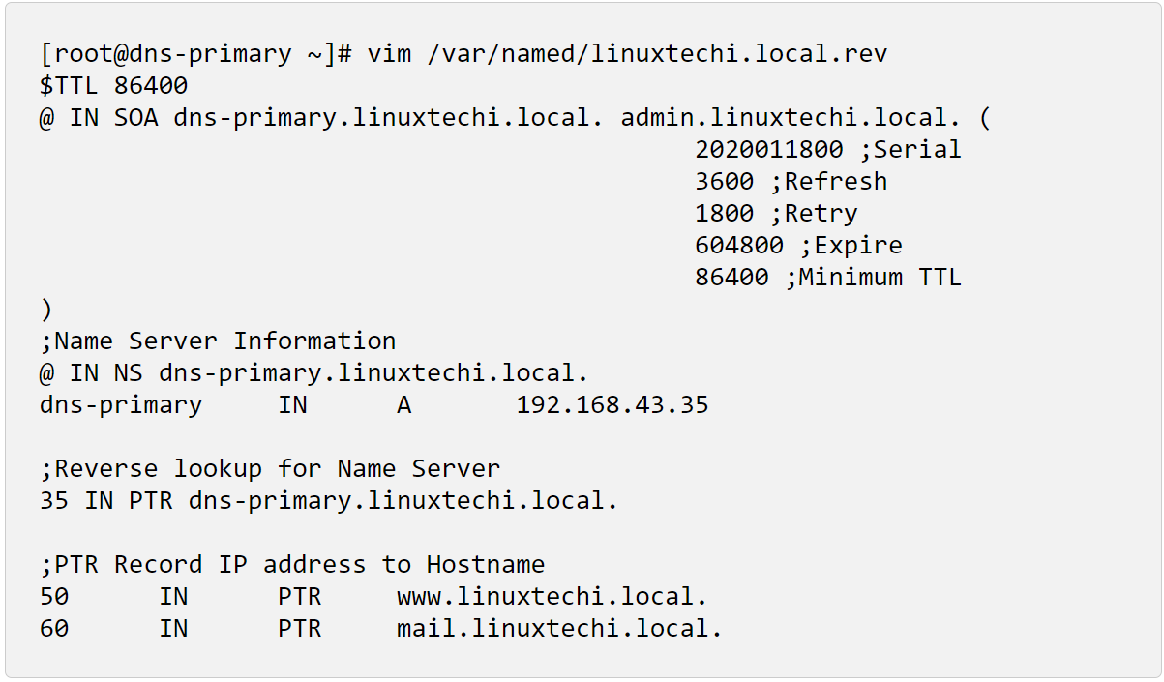

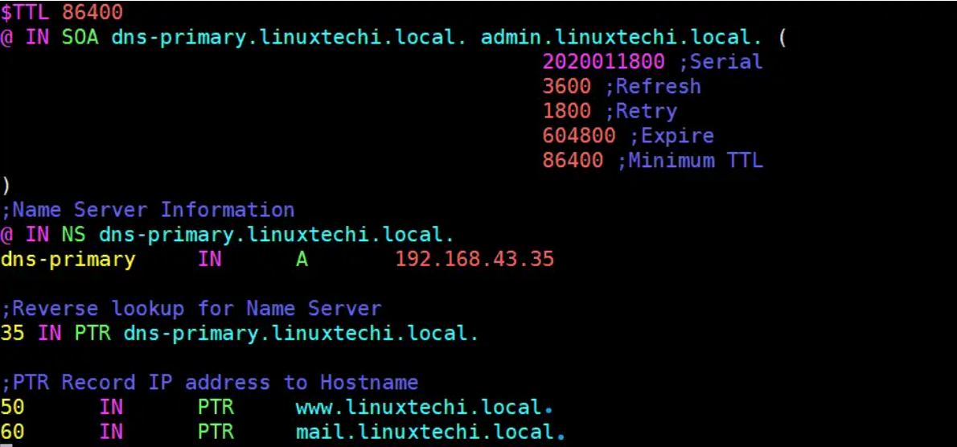

Next, assign the necessary file permissions to the two configuration files.

# chown named:named /var/named/linuxtechi.local.db

# chown named:named /var/named/linuxtechi.local.rev

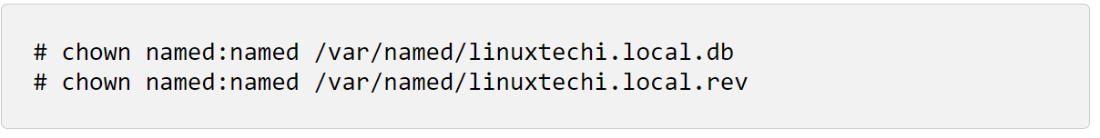

To confirm that the DNS zone lookup files are free from any syntactical errors, run the commands shown:

# named-checkconf

# named-checkzone linuxtechi.local /var/named/linuxtechi.local.db

# named-checkzone 10.1.10.206 /var/named/linuxtechi.local.rev

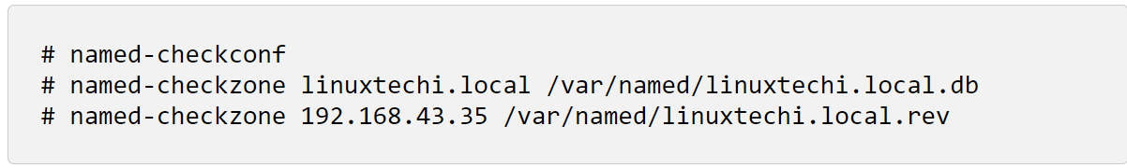

If there are no errors, you should get the output shown:

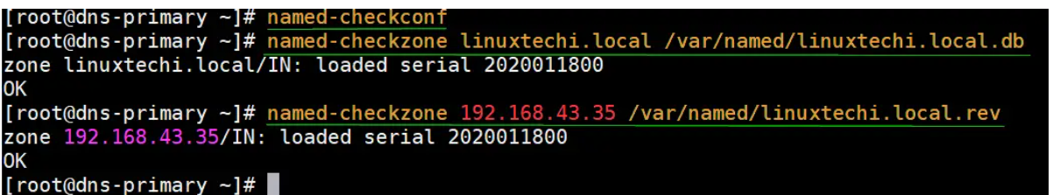

For the changes to be reflected in the system, restart the Bind DNS server

# systemctl restart named

For client systems to access the system we need to add the DNS service on the firewall and thereafter reload the firewall.

# firewall-cmd  --add-service=dns --zone=public  --permanent

# firewall-cmd --reload

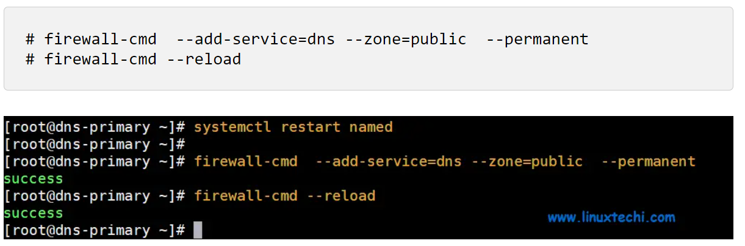

**Step 5: Test the Bind DNS server from a client system**

Having finalized the configuration on the DNS server, let’s head out to a client machine and perform a few tests.

On a client machine ( CentOS 8 / RHEL 8), open the **/etc/resolv.conf** file and edit the following parameter:

**nameserver 10.1.10.206**

As always, save & close the configuration file.

Lastly, you need to append the Bind DNS server’s IP address to the **/etc/sysconfig/network-scripts/ifcfg-enp0s3** file as shown.

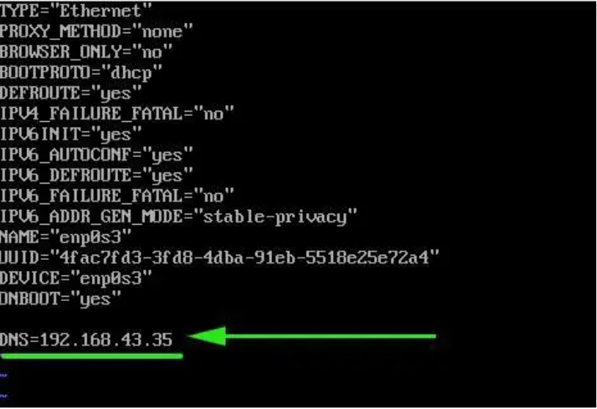

Save and close the config file and then restart the network manager service to make above change into the effect,

# systemctl restart NetworkManager

Using the nslookup command test the Bind DNS server as shown:

# nslookup dns-primary.linuxtechi.local

# nslookup mail.linuxtechi.local

# nslookup www.linuxtechi.local

# nslookup ftp.linuxtechi.local

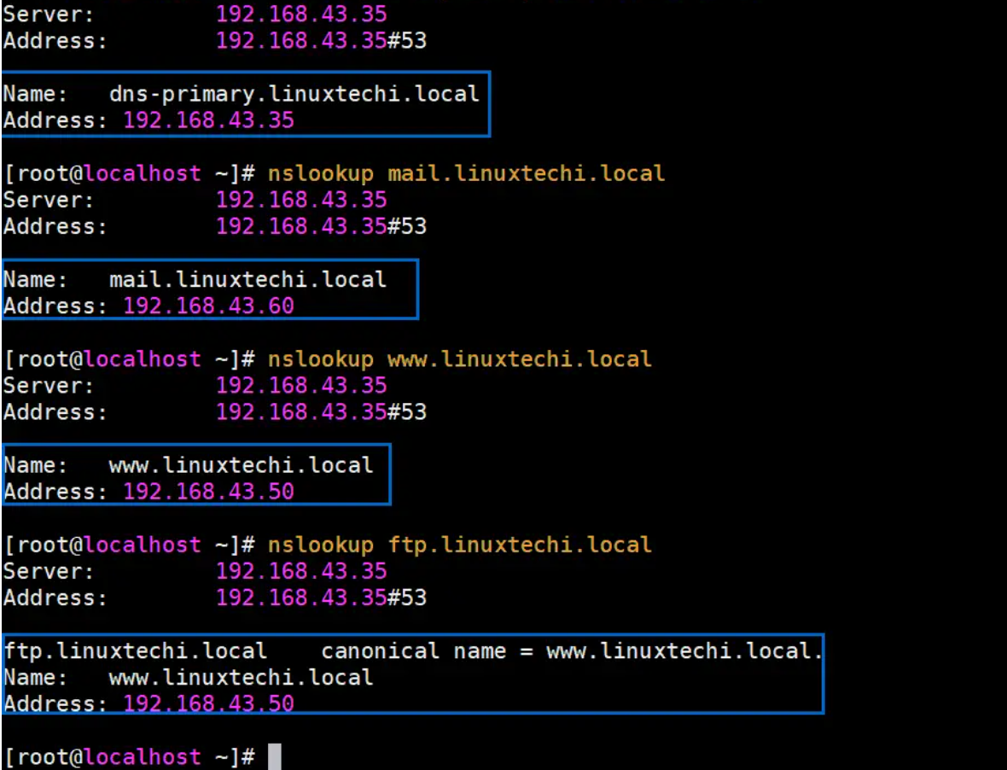

# nslookup 10.1.10.206

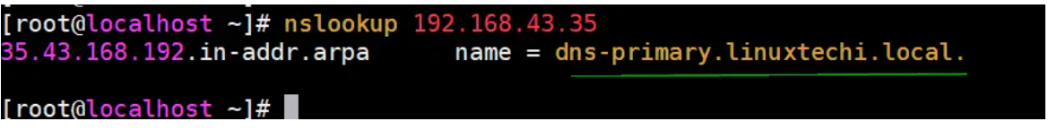

The output from the nslookup command confirms that the forward DNS lookup is working as expected.

Moreover, you can also use the dig command as shown

# dig dns-primary.linuxtechi.local

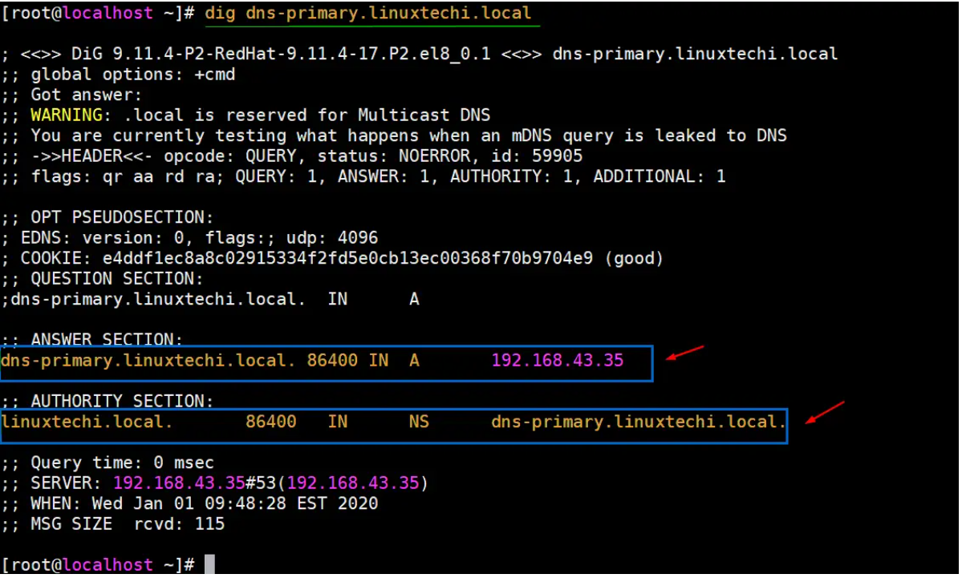

To perform a reverse DNS lookup, use the dig command as shown:

# dig -x 10.1.10.206

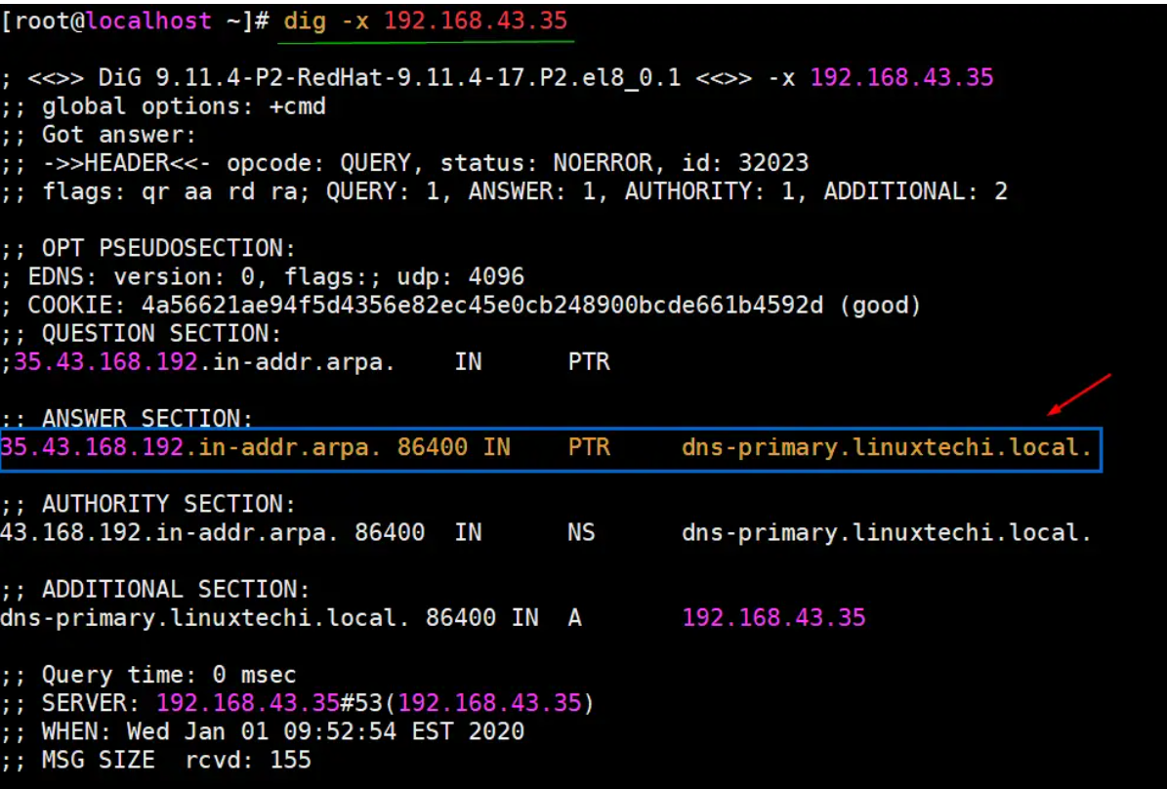

Perfect! The reverse DNS lookup is also working as we would expect.

**Appendix:**

388  hostname -d  
  389  hostname  
  390  uname -a  
  391  hostnamectl  
  392  history  
  393  vi /etc/named.conf  
  394  ll  
  395  vi tecmint.lan.db  
  396  vi tecmint.lan.rev  
  397  vi tecmint.lan.db  
  398  vi tecmint.lan.rev  
  399  named-checkconf  
  400  named-checkzone tecmint.lan /var/named/tecmint.lan.db  
  401  vi tecmint.lan.db  
  402  named-checkzone tecmint.lan /var/named/tecmint.lan.db  
  403  vi tecmint.lan.db  
  404  named-checkzone tecmint.lan /var/named/tecmint.lan.db  
  405  vi tecmint.lan.db  
  406  named-checkzone tecmint.lan /var/named/tecmint.lan.db  
  407  named-checkzone 10.1.10.206 /var/named/tecmint.lan.rev  
  408  firewall-cmd --permanent --add-service=dns --zone=public  
  409  firewall-cmd --reload  
  410  systemctl restart named  
  411  vi tecmint.lan.db  
  412  nslookup [dns.google.com](http://dns.google.com/)  
  413  history  
  
Files:  
vi /etc/named.conf  
----------  
  
//  
// named.conf  
//  
// Provided by Red Hat bind package to configure the ISC BIND named(8) DNS  
// server as a caching only nameserver (as a localhost DNS resolver only).  
//  
// See /usr/share/doc/bind*/sample/ for example named configuration files.  
//  
  
options {  
//      listen-on port 53 { 127.0.0.1; };  
//      listen-on-v6 port 53 { ::1; };  
        directory       "/var/named";  
        dump-file       "/var/named/data/cache_dump.db";  
        statistics-file "/var/named/data/named_stats.txt";  
        memstatistics-file "/var/named/data/named_mem_stats.txt";  
        secroots-file   "/var/named/data/named.secroots";  
        recursing-file  "/var/named/data/named.recursing";  
        allow-query     {10.1.10.206; [192.168.43.0/24](http://192.168.43.0/24); };  
  
        /*  
         - If you are building an AUTHORITATIVE DNS server, do NOT enable recursion.  
         - If you are building a RECURSIVE (caching) DNS server, you need to enable  
           recursion.  
         - If your recursive DNS server has a public IP address, you MUST enable access  
           control to limit queries to your legitimate users. Failing to do so will  
           cause your server to become part of large scale DNS amplification  
           attacks. Implementing BCP38 within your network would greatly  
           reduce such attack surface  
        */  
        recursion yes;  
  
        dnssec-enable yes;  
        dnssec-validation yes;  
  
        managed-keys-directory "/var/named/dynamic";  
        pid-file "/run/named/named.pid";  
        session-keyfile "/run/named/session.key";  
  
        /* <https://fedoraproject.org/wiki/Changes/CryptoPolicy> */  
        include "/etc/crypto-policies/back-ends/bind.config";  
};  
  
logging {  
        channel default_debug {  
                file "data/named.run";  
                severity dynamic;  
        };  
};  
  
zone "." IN {  
        type hint;  
        file "[named.ca](http://named.ca/)";  
};  
  
include "/etc/named.rfc1912.zones";  
include "/etc/named.root.key";  
  
//forward zone  
  
zone "otite-db-naagios" IN {  
        type master;  
        file "tecmint.lan.db";  
        allow-update { none;};  
        allow-query { any; };  
};  
  
//backward zone  
  
zone "10.1.10.195.in-addr.arpa" IN {  
        type master;  
        file "techmint.lan.rev";  
        allow-update { none; };  
        allow-query { any; };  
  
};  
  
----------  
vi tecmint.lan.db  
---  
  
  
---  
  
vi tecmint.lan.rev

-----Internet Articles----

**Introduction**

[DNS](https://phoenixnap.com/kb/what-is-domain-name-system) configuration sets up a Domain Name System server to translate domain names ([URLs](https://phoenixnap.com/glossary/url-definition-meaning)) into [IP addresses](https://phoenixnap.com/glossary/what-is-an-ip-address). The configuration helps manage the [DNS records](https://phoenixnap.com/kb/dns-record-types) for [domains](https://phoenixnap.com/glossary/what-is-a-domain).

Knowing how to configure a DNS server is essential for any [network administrator](https://phoenixnap.com/glossary/what-is-a-network-administrator). The steps to configure a DNS differs depending on the [operating system](https://phoenixnap.com/glossary/operating-system).

**This article shows how to configure DNS on a Windows, macOS, and Linux machine.**

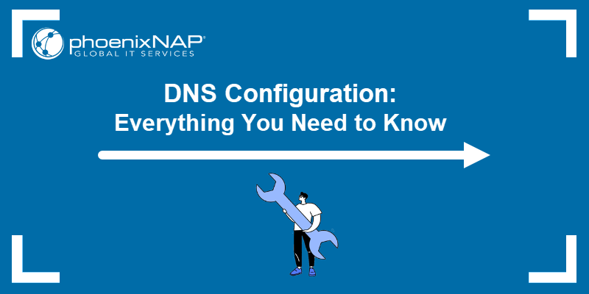

**Prerequisites**

* A stable internet connection.
* Access to an account with administrator privileges.
* Access to the command line/terminal.

**Why Change DNS Configuration?**

[Internet service providers](https://phoenixnap.com/glossary/isp-definition) use a preconfigured DNS server to filter traffic. There are many reasons to change the default DNS configuration, such as:

* **Speed improvements**. A DNS maps domain names to IP addresses. Custom DNS configuration helps improve domain name resolution times, which reduces the time needed to access a website.
* **Greater security**. Specific DNS servers block malicious web pages and focus on preventing access to [unsafe websites](https://phoenixnap.com/blog/how-to-secure-a-website). Changing the DNS configuration to use such servers improves internet security and restricts exposure to online threats.
* **Customized experience**. Configure the DNS to block access to specific web pages or reroute domain names to different addresses. For example, some DNS servers help create a family-friendly environment by blocking access to unsafe or suspicious websites.
* **Privacy**. Some DNS servers log internet queries for advertising purposes. Changing the DNS configuration to a privacy-focused server enables better control over online privacy.
* **Troubleshooting**. Changing to a different DNS server is crucial in [troubleshooting DNS issues](https://phoenixnap.com/kb/dns-troubleshooting).

There are many free [DNS resolvers](https://phoenixnap.com/glossary/dns-resolver) available. While some solely focus on [reducing DNS lookups](https://phoenixnap.com/kb/reduce-dns-lookups) and speed improvements, other resolvers aim to provide an additional security and filtering layer.

The table below shows example providers, the purpose of the DNS, and the [IPv4 and IPv6](https://phoenixnap.com/blog/ipv4-vs-ipv6) addresses:

| **Provider** | **Purpose** | **IPv4 Addresses** | **IPv6 Addresses** |
| --- | --- | --- | --- |
| Google | Speed improvements. | 8.8.8.8 8.8.4.4 | 2001:4860:4860::8888 2001:4860:4860::8844 |
| Cloudflare | Speed improvements. | 1.1.1.1 1.0.0.1 | 2606:4700:4700::1111 2606:4700:4700::1001 |
| Quad9 | Filters malware, [phishing](https://phoenixnap.com/blog/what-phishing-attack-how-to-identify-protect), and exploits. | 9.9.9.9 149.112.112.112 | 2620:fe::fe 2620:fe::9 |
| OpenDNS | Security filtering and user-defined policies. | 208.67.222.222 208.67.220.220 | 2620:119:35::35 2620:119:53::53 |

The table shows a brief list of popular DNS servers. Research further to find a DNS resolver for your use case.

**How to Change DNS Configuration on Windows**

Changing the DNS configuration on Windows OS requires **administrator privileges**. Below are instructions to change the DNS configuration on a Windows 10/11 or Windows Server machine.

**Windows 10/11**

To change the DNS configuration on Windows, do the following:

1. In the **Start** menu, search for **Network Status**.

2. Select **Change adapter options**.

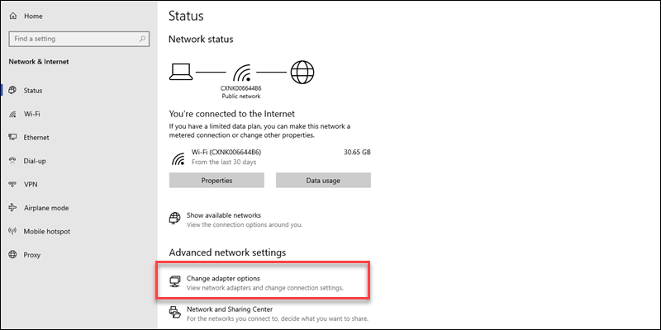

3. Right-click the network connection and open **Properties**.

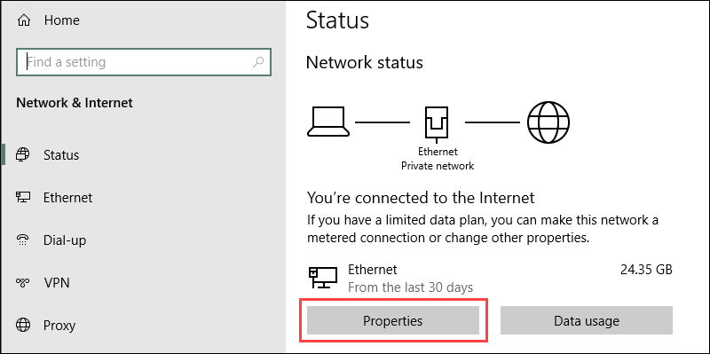

4. Locate and select the **Internet Protocol Version 4 (TCP/IPv4)** option from the list.

5. Click the **Properties** button to open the IPv4 settings.

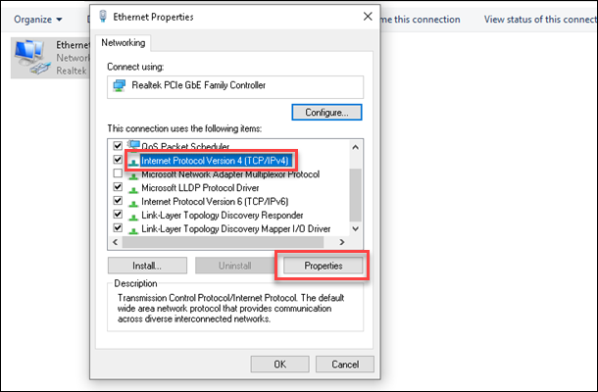

6. Select the **Use the following DNS server addresses** option.

7. Fill out the primary and secondary addresses. For example, to use Google's DNS resolver addresses, set **8.8.8.8** as preferred and **8.8.4.4** as alternate.

8. Click **OK** to save the changes.

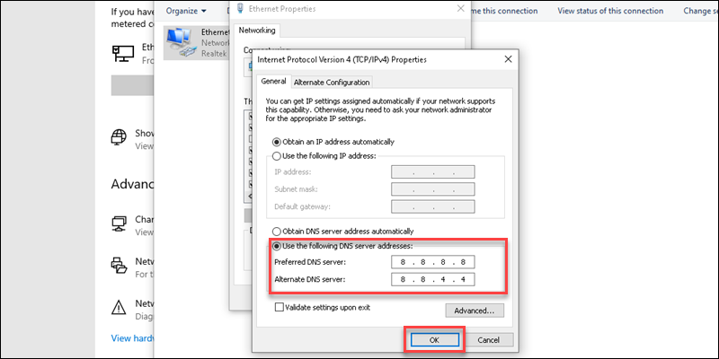

Restart the browser to apply the changes.

**Windows Server**

To change the DNS configuration on a Windows Server, follow the steps below:

1. Open the Start menu.

2. Search for **Control Panel** and press **Enter**.

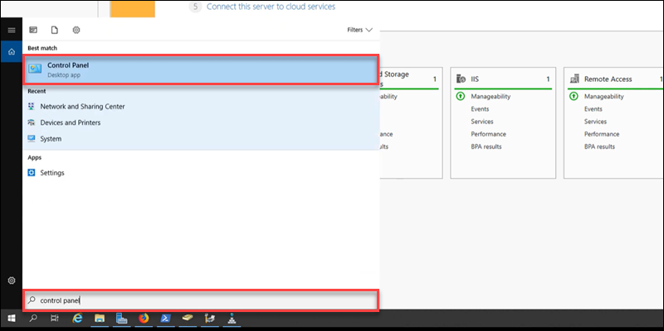

3. Open the **Network and Sharing Center**.

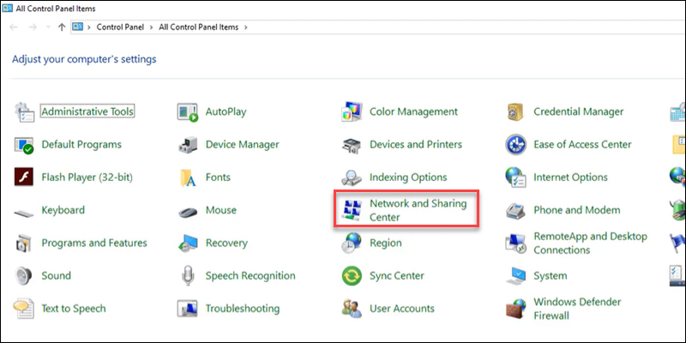

4. In the left pane, select **Change adapter settings**.

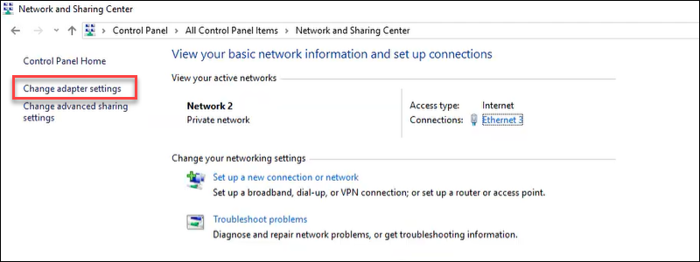

The steps after this are similar to Windows 10/11 machines.

5. Right-click the connection and open **Properties**.

6. Double-click the **Internet Protocol Version 4 (TCP/IPv4)** option on the list.

7. Set the preferred and alternate DNS server address in the fields, and click **OK** to apply the changes.

**Note:** If you use an Active Directory domain, enter the loopback address from the IP field and set up a DNS forwarder with the public DNS addresses instead.

**How to Change DNS Configuration on Linux**

The following steps work on Ubuntu 22.04. The steps can slightly differ between different [Linux distributions](https://phoenixnap.com/glossary/what-is-a-linux-distribution).

To permanently change the DNS configuration on Linux, do the following:

1. Open the terminal (**Ctrl**+**Alt**+**T**).

2. Open the *resolv.conf* file using a text editor, such as nano:

sudo nano /etc/resolv.conf

3. Add primary and alternate DNS addresses above the current configuration:

nameserver 8.8.8.8

nameserver 8.8.4.4

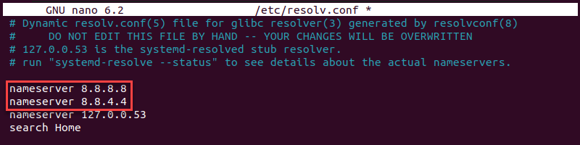

The addresses use Google's DNS resolver. Replace the IPs with your preferred DNS.

4. Save the file and close nano.

5. To ensure the changes persist after restarting the machine, use the **resolvconf** tool. Install it with the following command:

sudo apt install resolvconf

Wait for the installation to complete and proceed to the next step.

6. Start and enable the service with the following two commands:

sudo systemctl start resolvconf.service

sudo systemctl enable resolvconf.service

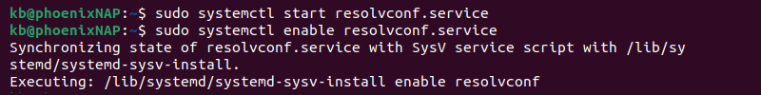

7. Edit the [configuration file](https://phoenixnap.com/glossary/config-file):

sudo nano /etc/resolvconf/resolv.conf.d/head

8. Add the following lines above all other configurations:

nameserver 8.8.8.8

nameserver 8.8.4.4

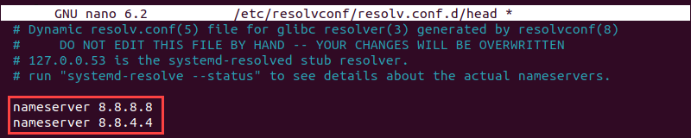

9. Save the file and close the text editor.

10. Restart the service:

sudo systemctl restart resolvconf.service

11. Confirm the changes applied:

resolvectl status

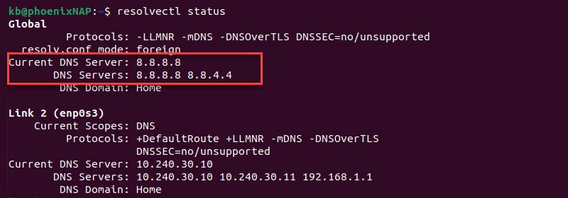

The addresses show as the current DNS server for the Global settings. Alternatively, run the [dig command](https://phoenixnap.com/kb/linux-dig-command-examples):

dig phoenixnap.com

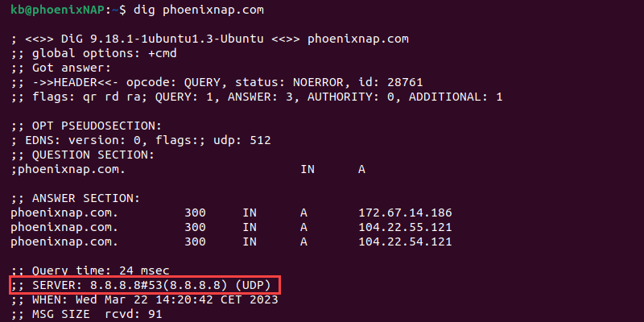

The **SERVER** section shows the DNS addresses.

**How to Change DNS Configuration on macOS**

To change the DNS configuration on macOS, follow the steps below:

1. Open **Apple Menu->System Settings**.

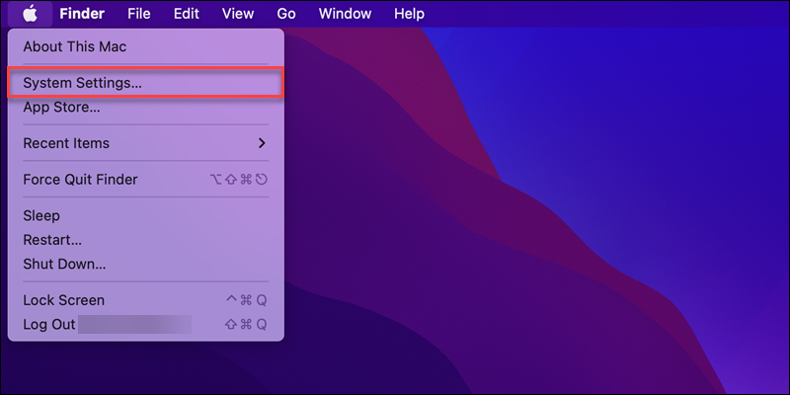

2. Open the **Network** settings from the left menu.

3. Choose the network from the list in the right pane (**Wi-Fi** or **Ethernet**).

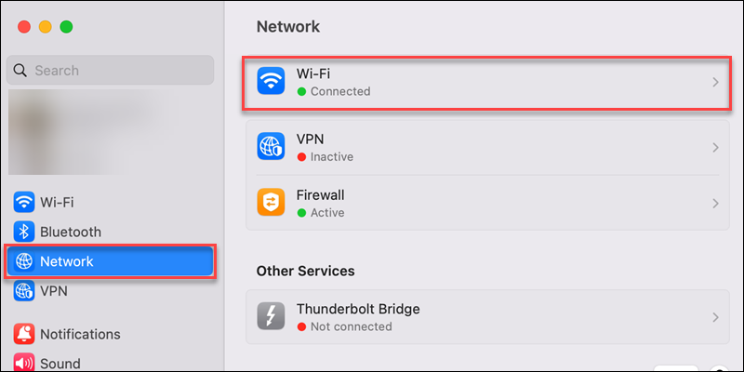

4. Click the **Details** button to view the connection settings.

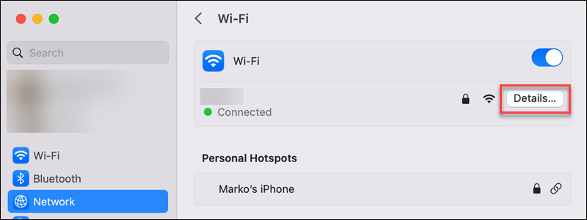

5. Switch to the **DNS** tab in the left pane.

6. Click the plus (**+**) button to add DNS server addresses.

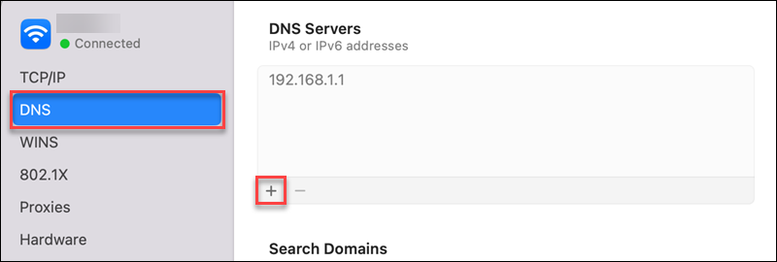

7. Add the primary and secondary addresses for the DNS server.

8. Click **OK** to save the changes and apply the settings.

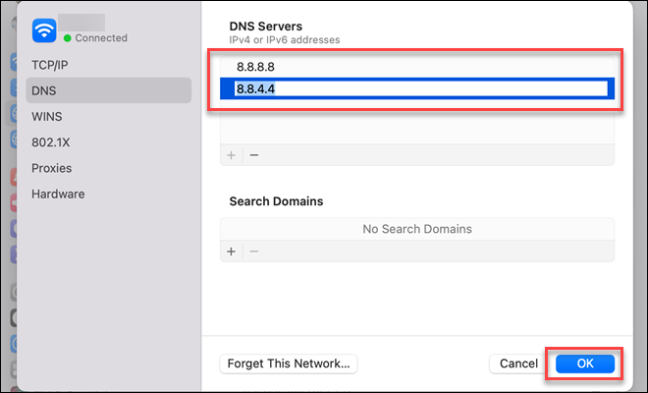

Restart the browser to test and see the changes.

**How to Change DNS Configuration on Router Level?**

Changing DNS configuration on a [router](https://phoenixnap.com/glossary/what-is-a-router) level affects all connected devices, such as computers, smartphones, and any additional smart device that uses Wi-Fi. Routers that manage multiple signals, such as a phone or TV signal, often do not allow changing [DNS settings](https://phoenixnap.com/glossary/what-is-dns-settings) at all.

The precise instructions to change the DNS configuration on a router are different for every model. **Check the router's instruction manual** to see if there are specific steps and guidelines. Alternatively, search for the router name and model and add the "change DNS configuration" phrase.

**Conclusion**

After going through the steps in this guide, you know how to set up a custom DNS configuration on three different operating systems. Configuring DNS comes with many benefits, and it is essential for proper network administration.

Next, read about the [best DNS practices for security and performance](https://phoenixnap.com/kb/dns-best-practices-security).

Article #2:

**What is DNS?**

The Domain Name System (DNS) is the phonebook of the Internet. Humans access information online through [domain names](https://www.cloudflare.com/learning/dns/glossary/what-is-a-domain-name/), like nytimes.com or espn.com. Web browsers interact through [Internet Protocol (IP)](https://www.cloudflare.com/learning/network-layer/internet-protocol/) addresses. DNS translates domain names to [IP addresses](https://www.cloudflare.com/learning/dns/glossary/what-is-my-ip-address/) so browsers can load Internet resources.

Each device connected to the Internet has a unique IP address which other machines use to find the device. DNS servers eliminate the need for humans to memorize IP addresses such as 192.168.1.1 (in IPv4), or more complex newer alphanumeric IP addresses such as 2400:cb00:2048:1::c629:d7a2 (in IPv6).



**How does DNS work?**

The process of DNS resolution involves converting a hostname (such as www.example.com) into a computer-friendly IP address (such as 192.168.1.1). An IP address is given to each device on the Internet, and that address is necessary to find the appropriate Internet device - like a street address is used to find a particular home. When a user wants to load a webpage, a translation must occur between what a user types into their web browser (example.com) and the machine-friendly address necessary to locate the example.com webpage.

In order to understand the process behind the DNS resolution, it’s important to learn about the different hardware components a DNS query must pass between. For the web browser, the DNS lookup occurs "behind the scenes" and requires no interaction from the user’s computer apart from the initial request.

**Report**

2023 GigaOm Radar for DNS Security

[Get the report](https://www.cloudflare.com/lp/gigaom-radar-dns-security/)

**Talk to an expert**

Learn how Cloudflare can protect your business

[Contact sales](https://www.cloudflare.com/plans/enterprise/contact/)

**There are 4 DNS servers involved in loading a webpage:**

* [DNS recursor](https://www.cloudflare.com/learning/dns/dns-server-types/) - The recursor can be thought of as a librarian who is asked to go find a particular book somewhere in a library. The DNS recursor is a server designed to receive queries from client machines through applications such as web browsers. Typically the recursor is then responsible for making additional requests in order to satisfy the client’s DNS query.
* **Root nameserver** - The [root server](https://www.cloudflare.com/learning/dns/glossary/dns-root-server/) is the first step in translating (resolving) human readable host names into IP addresses. It can be thought of like an index in a library that points to different racks of books - typically it serves as a reference to other more specific locations.
* [TLD nameserver](https://www.cloudflare.com/learning/dns/dns-server-types/) - The top level domain server ([TLD](https://www.cloudflare.com/learning/dns/top-level-domain/)) can be thought of as a specific rack of books in a library. This nameserver is the next step in the search for a specific IP address, and it hosts the last portion of a hostname (In example.com, the TLD server is “com”).
* [Authoritative nameserver](https://www.cloudflare.com/learning/dns/dns-server-types/) - This final nameserver can be thought of as a dictionary on a rack of books, in which a specific name can be translated into its definition. The authoritative nameserver is the last stop in the nameserver query. If the authoritative name server has access to the requested record, it will return the IP address for the requested hostname back to the DNS Recursor (the librarian) that made the initial request.

**Fast & Secure DNS**

Free DNS included with any Cloudflare plan

[Get started free](https://www.cloudflare.com/plans/)

**What's the difference between an authoritative DNS server and a recursive DNS resolver?**

Both concepts refer to servers (groups of servers) that are integral to the DNS infrastructure, but each performs a different role and lives in different locations inside the pipeline of a DNS query. One way to think about the difference is the [recursive](https://www.cloudflare.com/learning/dns/what-is-recursive-dns/) resolver is at the beginning of the DNS query and the authoritative nameserver is at the end.

**Recursive DNS resolver**

The recursive resolver is the computer that responds to a recursive request from a client and takes the time to track down the [DNS record](https://www.cloudflare.com/learning/dns/dns-records/). It does this by making a series of requests until it reaches the authoritative DNS nameserver for the requested record (or times out or returns an error if no record is found). Luckily, recursive DNS resolvers do not always need to make multiple requests in order to track down the records needed to respond to a client; [caching](https://www.cloudflare.com/learning/cdn/what-is-caching/) is a data persistence process that helps short-circuit the necessary requests by serving the requested resource record earlier in the DNS lookup.

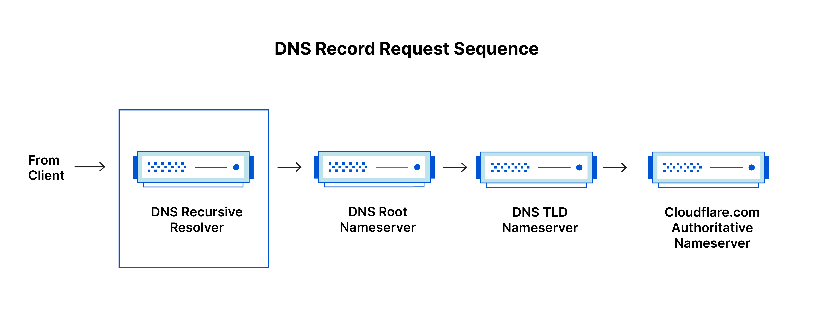

**Authoritative DNS server**

Put simply, an authoritative DNS server is a server that actually holds, and is responsible for, DNS resource records. This is the server at the bottom of the DNS lookup chain that will respond with the queried resource record, ultimately allowing the web browser making the request to reach the IP address needed to access a website or other web resources. An authoritative nameserver can satisfy queries from its own data without needing to query another source, as it is the final source of truth for certain DNS records.

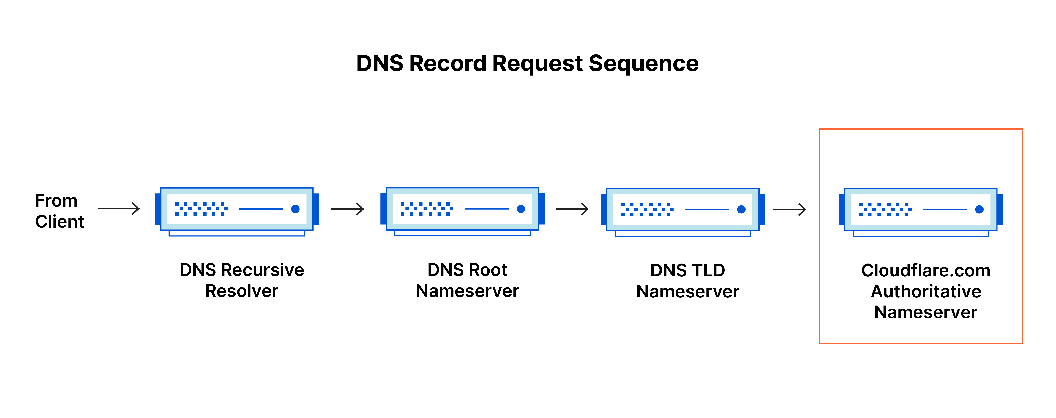

It’s worth mentioning that in instances where the query is for a subdomain such as foo.example.com or [blog.cloudflare.com](https://blog.cloudflare.com/), an additional nameserver will be added to the sequence after the authoritative nameserver, which is responsible for storing the subdomain’s [CNAME record](https://www.cloudflare.com/learning/dns/dns-records/dns-cname-record/).

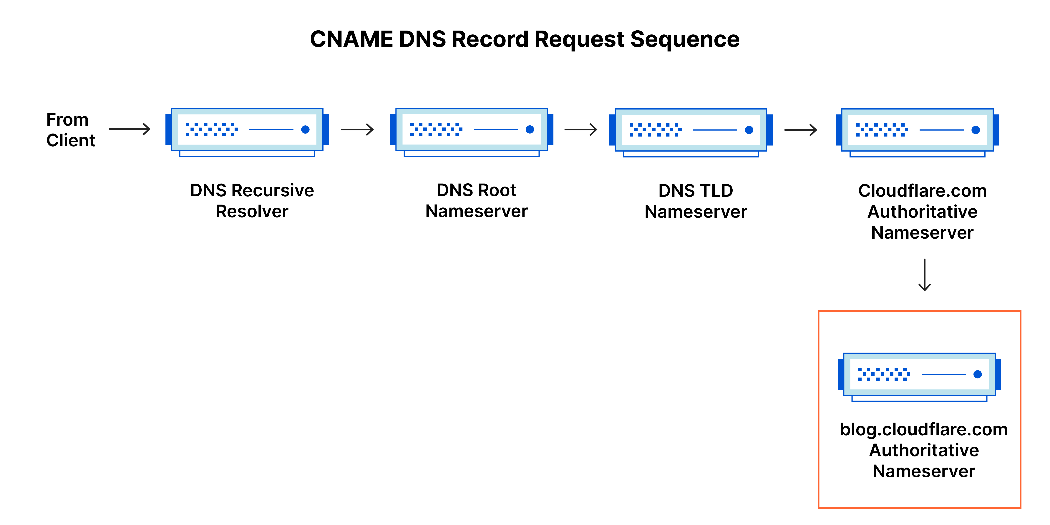

There is a key difference between many DNS services and the one that Cloudflare provides. Different DNS recursive resolvers such as Google DNS, OpenDNS, and providers like Comcast all maintain data center installations of DNS recursive resolvers. These resolvers allow for quick and easy queries through optimized clusters of DNS-optimized computer systems, but they are fundamentally different than the nameservers hosted by Cloudflare.

Cloudflare maintains infrastructure-level nameservers that are integral to the functioning of the Internet. One key example is the [f-root server network](https://blog.cloudflare.com/f-root/) which Cloudflare is partially responsible for hosting. The F-root is one of the root level DNS nameserver infrastructure components responsible for the billions of Internet requests per day. Our [Anycast network](https://www.cloudflare.com/learning/cdn/glossary/anycast-network/) puts us in a unique position to handle large volumes of DNS traffic without service interruption.

**What are the steps in a DNS lookup?**

For most situations, DNS is concerned with a domain name being translated into the appropriate IP address. To learn how this process works, it helps to follow the path of a DNS lookup as it travels from a web browser, through the DNS lookup process, and back again. Let's take a look at the steps.

Note: Often DNS lookup information will be cached either locally inside the querying computer or remotely in the DNS infrastructure. There are typically 8 steps in a DNS lookup. When DNS information is cached, steps are skipped from the DNS lookup process which makes it quicker. The example below outlines all 8 steps when nothing is cached.

**The 8 steps in a DNS lookup:**

1. A user types ‘example.com’ into a web browser and the query travels into the Internet and is received by a DNS recursive resolver.
2. The resolver then queries a DNS root nameserver (.).
3. The root server then responds to the resolver with the address of a Top Level Domain (TLD) DNS server (such as .com or .net), which stores the information for its domains. When searching for example.com, our request is pointed toward the .com TLD.
4. The resolver then makes a request to the .com TLD.
5. The TLD server then responds with the IP address of the domain’s nameserver, example.com.
6. Lastly, the recursive resolver sends a query to the domain’s nameserver.
7. The IP address for example.com is then returned to the resolver from the nameserver.
8. The DNS resolver then responds to the web browser with the IP address of the domain requested initially.

Once the 8 steps of the DNS lookup have returned the IP address for example.com, the browser is able to make the request for the web page:

1. The browser makes a [HTTP](https://www.cloudflare.com/learning/ddos/glossary/hypertext-transfer-protocol-http/) request to the IP address.
2. The server at that IP returns the webpage to be rendered in the browser (step 10).

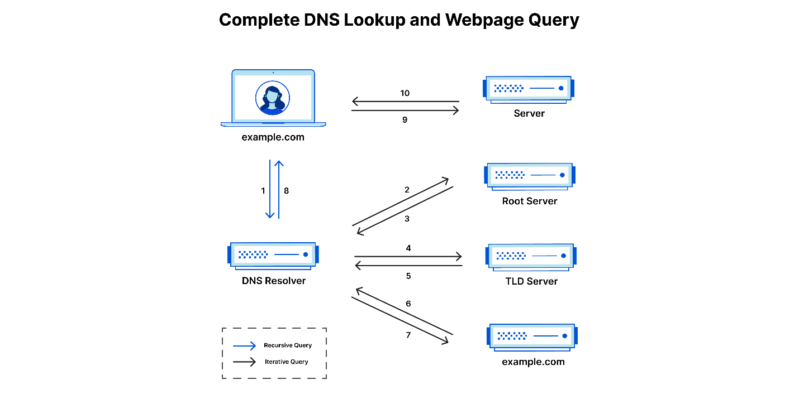

**What is a DNS resolver?**

The DNS resolver is the first stop in the DNS lookup, and it is responsible for dealing with the client that made the initial request. The resolver starts the sequence of queries that ultimately leads to a URL being translated into the necessary IP address.

Note: A typical uncached DNS lookup will involve both recursive and iterative queries.

It's important to differentiate between a [recursive DNS](https://www.cloudflare.com/learning/dns/what-is-recursive-dns/) query and a recursive DNS resolver. The query refers to the request made to a DNS resolver requiring the resolution of the query. A DNS recursive resolver is the computer that accepts a recursive query and processes the response by making the necessary requests.

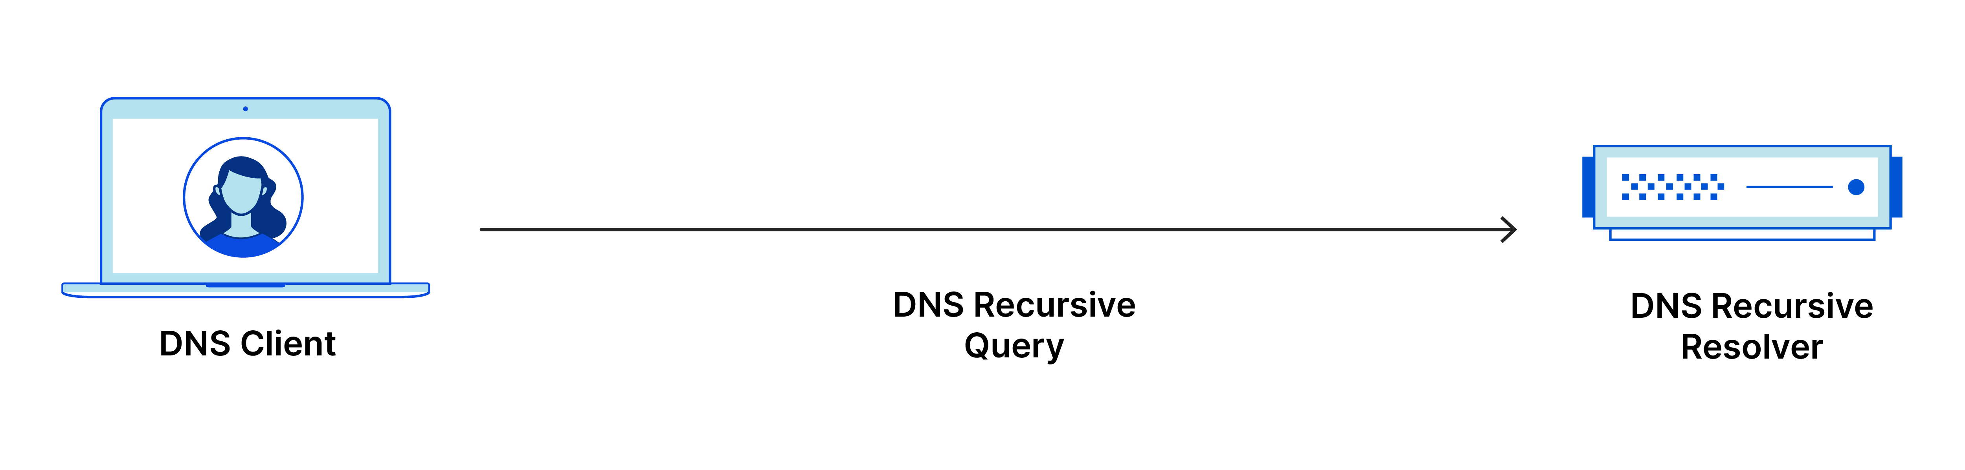

**What are the types of DNS queries?**

In a typical DNS lookup three types of queries occur. By using a combination of these queries, an optimized process for DNS resolution can result in a reduction of distance traveled. In an ideal situation cached record data will be available, allowing a DNS name server to return a non-recursive query.

**3 types of DNS queries:**

1. **Recursive query** - In a recursive query, a DNS client requires that a DNS server (typically a DNS recursive resolver) will respond to the client with either the requested resource record or an error message if the resolver can't find the record.
2. **Iterative query** - in this situation the DNS client will allow a DNS server to return the best answer it can. If the queried DNS server does not have a match for the query name, it will return a referral to a DNS server authoritative for a lower level of the domain namespace. The DNS client will then make a query to the referral address. This process continues with additional DNS servers down the query chain until either an error or timeout occurs.
3. **Non-recursive query** - typically this will occur when a DNS resolver client queries a DNS server for a record that it has access to either because it's authoritative for the record or the record exists inside of its cache. Typically, a DNS server will cache DNS records to prevent additional bandwidth consumption and load on upstream servers.

**What is DNS caching? Where does DNS caching occur?**

The purpose of caching is to temporarily stored data in a location that results in improvements in performance and reliability for data requests. DNS caching involves storing data closer to the requesting client so that the DNS query can be resolved earlier and additional queries further down the DNS lookup chain can be avoided, thereby improving load times and reducing bandwidth/CPU consumption. DNS data can be cached in a variety of locations, each of which will store DNS records for a set amount of time determined by a [time-to-live (TTL)](https://www.cloudflare.com/learning/cdn/glossary/time-to-live-ttl/).

**Browser DNS caching**

Modern web browsers are designed by default to cache DNS records for a set amount of time. The purpose here is obvious; the closer the DNS caching occurs to the web browser, the fewer processing steps must be taken in order to check the cache and make the correct requests to an IP address. When a request is made for a DNS record, the browser cache is the first location checked for the requested record.

In Chrome, you can see the status of your DNS cache by going to chrome://net-internals/#dns.

**Operating system (OS) level DNS caching**

The operating system level DNS resolver is the second and last local stop before a DNS query leaves your machine. The process inside your operating system that is designed to handle this query is commonly called a “stub resolver” or DNS client. When a stub resolver gets a request from an application, it first checks its own cache to see if it has the record. If it does not, it then sends a DNS query (with a recursive flag set), outside the local network to a DNS recursive resolver inside the Internet service provider (ISP).

When the recursive resolver inside the ISP receives a DNS query, like all previous steps, it will also check to see if the requested host-to-IP-address translation is already stored inside its local persistence layer.

The recursive resolver also has additional functionality depending on the types of records it has in its cache:

1. If the resolver does not have the [A records](https://www.cloudflare.com/learning/dns/dns-records/dns-a-record/), but does have the [NS records](https://www.cloudflare.com/learning/dns/dns-records/dns-ns-record/) for the authoritative nameservers, it will query those name servers directly, bypassing several steps in the DNS query. This shortcut prevents lookups from the root and .com nameservers (in our search for example.com) and helps the resolution of the DNS query occur more quickly.
2. If the resolver does not have the NS records, it will send a query to the TLD servers (.com in our case), skipping the root server.
3. In the unlikely event that the resolver does not have records pointing to the TLD servers, it will then query the root servers. This event typically occurs after a DNS cache has been purged.

Learn about what differentiates [Cloudflare DNS](https://www.cloudflare.com/dns/) from other DNS providers.

Articles:

**Q: How can I effectively configure DNS on a Linux system, and what are the key considerations and commands to master?**

**A: Navigating Linux DNS Configuration:**

1. **What are the fundamental components of DNS, and how does the resolution process work?** DNS involves servers, resolvers, and authoritative servers, with a hierarchical resolution process.
2. **Which configuration files play a role in Linux DNS, and what are their purposes?** Understand the roles of /etc/hosts and /etc/resolv.conf in local hostname resolution and resolver configuration.
3. **How do I configure DNS servers on Linux using Bind and dnsmasq?** Utilize configuration files like /etc/named.conf for Bind and /etc/dnsmasq.conf for dnsmasq.
4. **What security measures should be implemented in Linux DNS, such as DNSSEC and firewall configuration?** Enhance security with DNSSEC and configure firewalls to allow DNS traffic on the necessary ports.
5. **How can I troubleshoot DNS issues on a Linux system, and what commands are helpful?** Troubleshoot using commands like nslookup and dig, and review DNS server logs for debugging.
6. **What are the best practices for optimizing DNS configuration on Linux?** Implement local DNS caching, keep software updated, and consider Split-Horizon DNS for enhanced security.